iMDGAVis: A shiny web application to efficiently perform popular visualization and analysis for Metagenomic data

**Tutorial for iMDGAVis**

interactive Metagenome Data Analysis and Visualization (**iMGDAVis**) application analyzes 16S and whole metagenome sequence results at various levels (kingdom to species). It is a browser-based and user-friendly R Shiny application for researchers to analyze and visualize without programming proficiency. It comprises six functional analyses.

1. Data Summary and Distribution
2. Diversity analysis
3. Dimension reduction
4. Correlation analysis
5. Heatmap
6. Differential abundance (Two and multiple groups)

In this tutorial, we will go through the installation and usage of each functional module using the example dataset. The **iMGDAVis** is publicly available at (). The example dataset is provided on the GitHub page ().

**How to start iMGDAVis locally**  
Download the **iMGDAVis** application locally from the GitHub page ().

Requirement:

* R (≥ 4.3.1), available at (<https://www.r-project.org/>)
* RStudio (≥ 2023.09.0) available at (<https://posit.co/download/rstudio-desktop/>)
* Bioconductor (3.17) and
* Shiny (≥ 1.7.5)

This Application was tested in Linux (Red Hat) and Windows 10

Start an R session using RStudio and run the following commands to install the shiny package:  
install.packages("shiny")

To run **iMGDAVis** by the following commands in R:  
library(shiny)  
shiny::runGitHub("**iMGDAVis** ","gudalab")

Or

Alternatively, download the source code from GitHub and run the following command in the R session using RStudio:

library(shiny)

runApp('/path/to/the/iMGDAVis-master', launch.browser=TRUE)

The Interface of iMDGAVis will pop up. See **Figure S1**

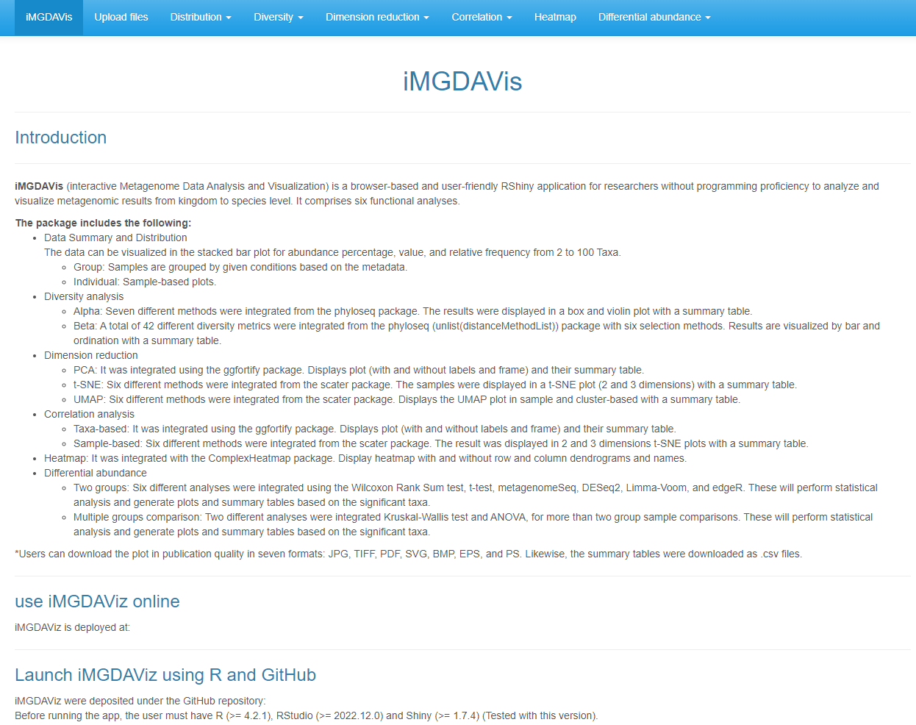

**Figure S1**: Interface of iMDGAVis application

**Table S1. List of R packages used to develop this application**

|  |  |  |  |
| --- | --- | --- | --- |
| **R Packages** | **Used for** | **Citation** | **Web link** |
| shiny | To develop the web and interactive application | (Chang et al., 2022) | <https://github.com/rstudio/shiny> |
| DT | Interface to the data tables | (Xie et al., 2022) | <https://github.com/rstudio/DT> |
| shinyFiles | A server-side file system viewer for shiny | (Pedersen et al., 2022) | <https://github.com/thomasp85/shinyFiles> |
| shinythemes | To use the shiny themes | (Chang 2021) | <https://github.com/rstudio/shinythemes> |
| ggplot2 | To create plots and graphics | (Wickham 2016) | <https://github.com/tidyverse/ggplot2> |
| phyloseq | To explore microbiome profiles for alpha and beta diversity | (McMurdie and Holmes, 2013) | <https://github.com/joey711/phyloseq> |
| ggpubr | Do the graphics for the correlation plot | (Kassambara 2022) | <https://github.com/kassambara/ggpubr> |
| vegan | The beta diversity orientation methods | (Oksanen et al., 2017) | <https://github.com/vegandevs/vegan> |
| ggfortify | To plot PCA in 2D | (Tang et al., 2016) | <https://github.com/sinhrks/ggfortify> |
| plotly | To plot PCA in 3D | (Sievert 2020) | <https://github.com/plotly/plotly.R> |
| ggplotify | Convert plot to ggplot object | (Yu 2021) | <https://github.com/GuangchuangYu/ggplotify> |
| reshape2 | To transform data into a different structure | Wickham H (2007) | <https://github.com/hadley/reshape> |
| tibble | To convert row names to column | (Müller and Wickham 2022). | <https://github.com/tidyverse/tibble> |
| scales | Scale functions visualization in a heatmap | (Wickham and Seidel, 2022) | <https://github.com/r-lib/scales> |
| dunn.test | Multiple comparisons using rank sums (used in the Kruskal-Wallis test) | (Dinno 2017) | <https://github.com/cran/dunn.test> |
| tidyr | Creating tidy data, where each column is a variable, each row is an observation | (Wickham and Girlich 2022) | <https://github.com/tidyverse/tidyr> |
| dplyr | Data manipulation: adds new variables that are functions of existing variables | (Wickham et al., 2022) | <https://github.com/tidyverse/dplyr> |
| devtools | To install several R packages | (Wickham et al., 2022) |  |
| patchwork | Adding multiple plots together | (Pedersen 2022) | <https://github.com/thomasp85/patchwork> |
| GGally | Creating correlation plots | (Schloerke et al., 2022) | <https://github.com/ggobi/ggally> |
| BiocManager | To install Bioconductor packages | (Morgan 2022) | [https://bioconductor.org/packages/BiocVersion/](https://www.bioconductor.org/packages/BiocVersion/) |
| ComplexHeatmap | Creating heatmap | (Gu 2022) | [https://bioconductor.org/packages/ComplexHeatmap/](https://www.bioconductor.org/packages/ComplexHeatmap/) |
| qvalue | Estimates for false discovery used in statistical analysis | (Storey et al., 2022) | <https://bioconductor.org/packages/qvalue/> |
| DESeq2 | Statistical analysis for two groups or sets | (Love et al., 2014) | <https://bioconductor.org/packages/DESeq2/> |
| edgeR | Statistical analysis for two groups or sets | (Robinson et al., 2010) | <https://bioconductor.org/packages/edgeR/> |
| limma | Statistical analysis for two groups or sets | (Ritchie et al., 2015) | <https://bioconductor.org/packages/limma/> |
| metagenomeSeq | Statistical analysis for two groups or sets | (Paulson et al., 2013) | [https://bioconductor.org/packages/metagenomeSeq/](https://www.bioconductor.org/packages/metagenomeSeq/) |
| bluster | Used in UMAP for creating k-means and graph-based clustering | (Lun 2022) | [https://bioconductor.org/packages/bluster/](https://www.bioconductor.org/packages/bluster/) |
| mia | Used for data wrangling in t-SNE and UMAP | (Ernst et al., 2022) | [https://bioconductor.org/packages/mia/](https://www.bioconductor.org/packages/mia/) |
| scater | Creating t-SNE and UMAP plots | (McCarthy et al., 2017) | [https://bioconductor.org/packages/scater/](https://www.bioconductor.org/packages/scater/) |
| microbiome | Utilities for microbiome analysis | (Lahti et al., 2019) | <https://bioconductor.org/packages/microbiome/> |
| microbiomeutilities | Pairwise comparison using a non-parametric test (Wilcoxon test) in alpha diversity | (Shetty and Lahti, 2022) | <https://github.com/microbiome/microbiome/> |

**Data preparation**

This section will introduce how to prepare input data sets: read counts with complete taxonomy (kingdom to species level) and corresponding metadata.

**Counts and metadata input formats**

Our application will accept the files in .txt, .tsv, or .csv format. The user can directly upload level 7 of Qiime2 results generated using Greengenes or Silva. Likewise, it will support MEGAN data from the whole metagenome sequence (remove the metadata column if it is included in the level7.csv file from Qiime2). If the user has a different output format, they need to prepare their data count file and metadata for analysis. For the file preparation, please refer to our example count data and metadata files from the upload files pages shown in **Figure S2** or example datasets from the GitHub repository (). The metadata files contain two columns. The first column contains the Samples which need to match the sample IDs in the count data input (**Figure S2**). The second column is Condition which indicates any user-specified categorial variable, such as "case" and "control" (two or multiple groups).

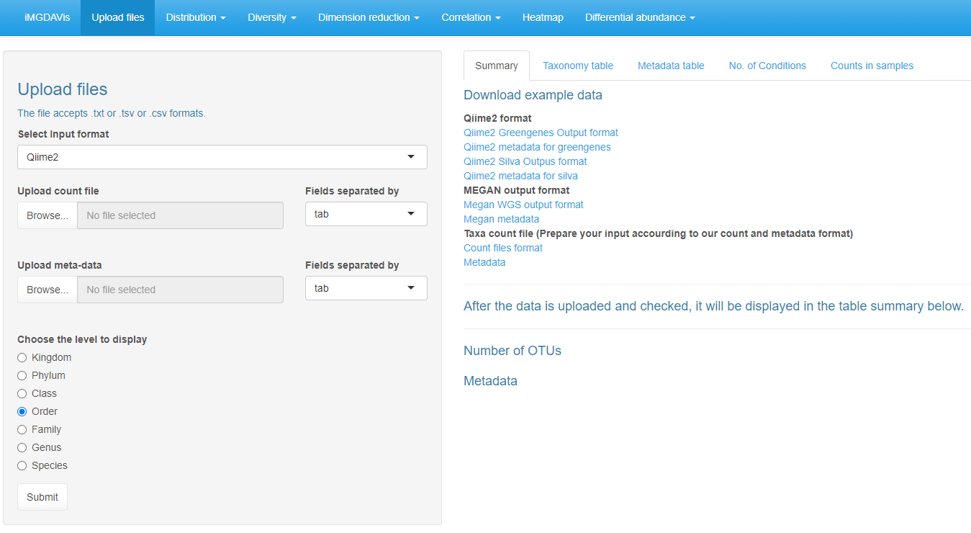

Example data

**Figure S2**: Example data were provided for Qiime2, MEGAN output format. If users have a different output format, prepare the files according to the taxa count file format

**Run iMGDAVis**

This section will introduce step-by-step instructions for each functional analysis using the example dataset provided at the iMGDAVis GitHub repository (). Using our application, users can download the plot in publication quality in seven formats: JPG, TIFF, PDF, SVG, BMP, EPS, and PS. The summary tables were displayed using the DT package to visualize up to 100 rows (default 10) and download the table in .csv files.

This tutorial is described with the MEGAN output files (Megan WGS output format and Megan metadata) available on the Upload files page.

**Data upload and their summary**

In the "Upload files" tab, the user must select the file format and click the browse button to upload the count and metadata. Then, select the taxonomy level and click the submit button to analyze the metagenomic data. The summary page will provide the following details.

Summary of count data and metadata, Taxonomy tables, metadata tables, No. of conditions, count in samples (**Figure S3 – S7**).

Summary tables

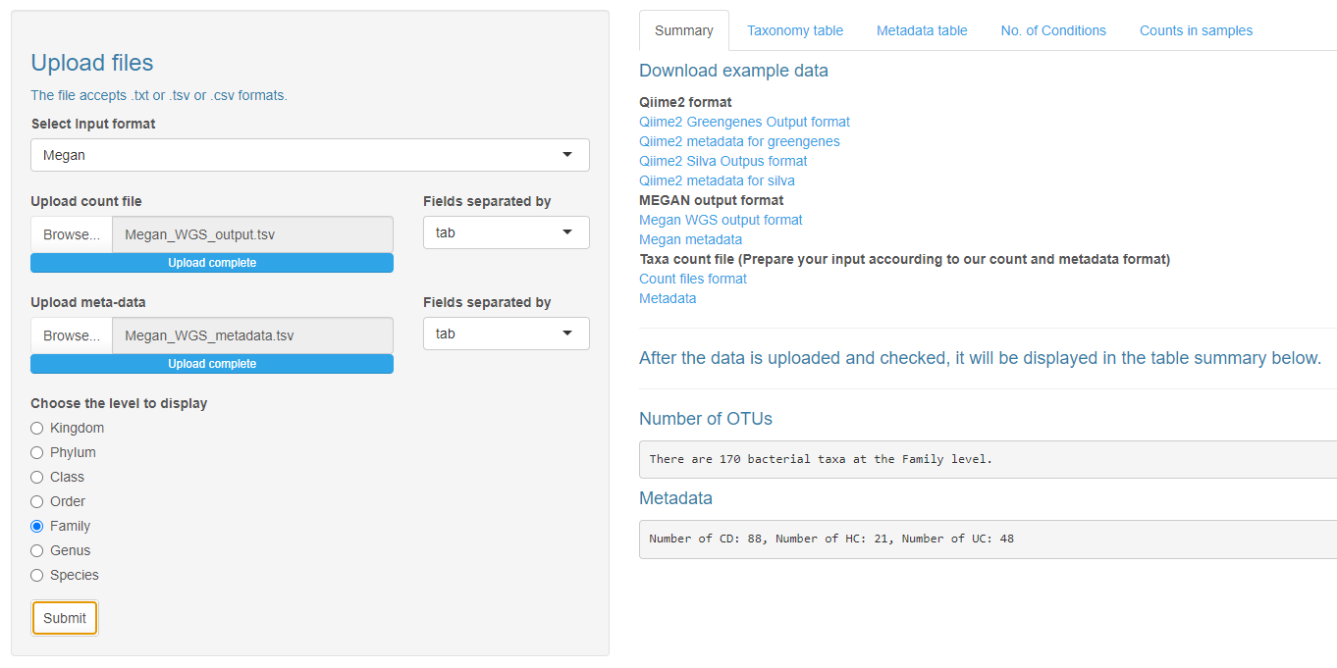

Select levels for analysis

tab, comma, space data

Input files & format (txt, tsv, csv)

Summary of count data and metadata

**Figure S3**: Data upload page and their summary

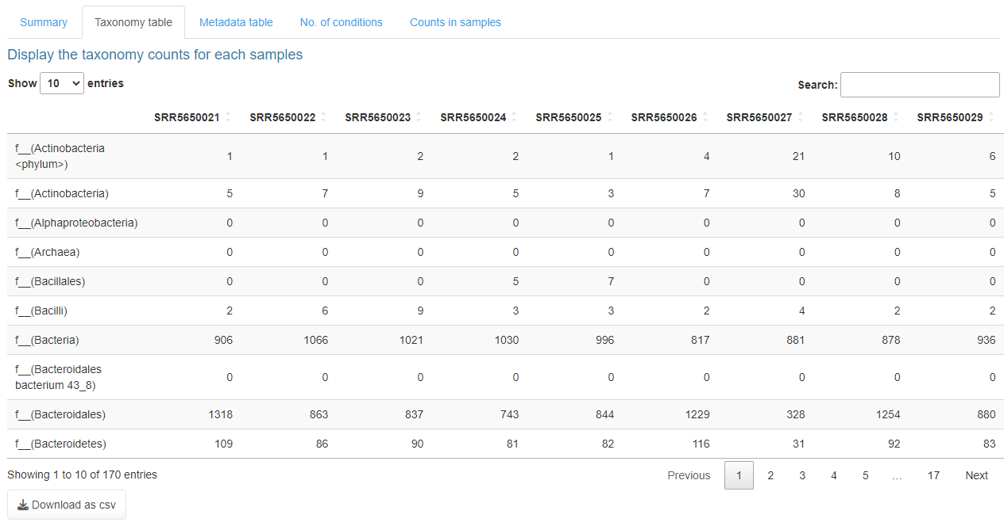 **Figure S4**: Summary of selected taxonomy table with their counts for each sample

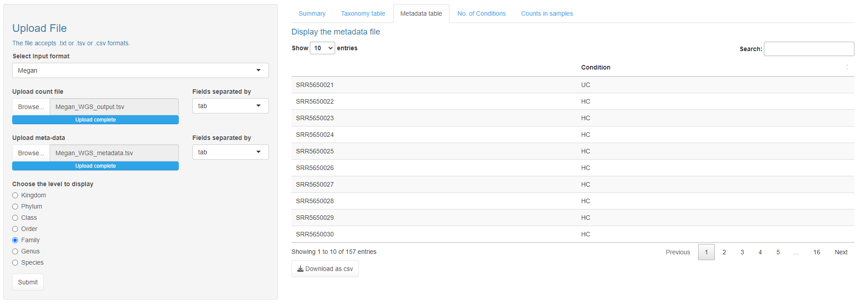

**Figure S5**: Summary of metadata table

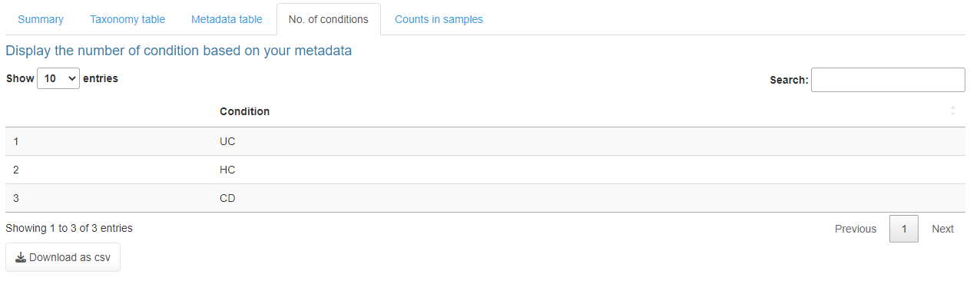

**Figure S6**: Display the no. of conditions based on the metadata

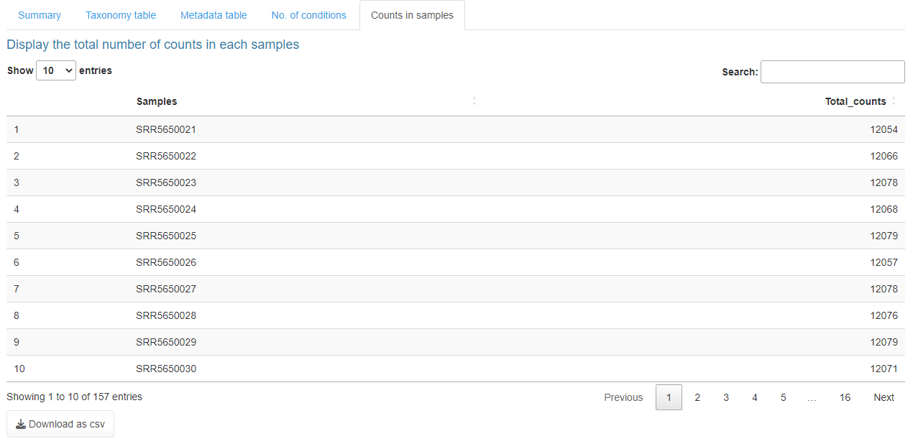

**Figure S7**: Display the total no. of counts based on the count file

After uploading the count data, metadata file and pre-selected level, the inputs will be automatically saved for accessing the distribution, diversity, dimension reduction, correlation, heatmap and differential abundance tabs.

**Distribution:**

Under the distribution tab, user can visualize their taxa (two to 100) by grouped (based on the Condition) or individual (based on the individual samples).

**Distribution based on groups:**

Users need to select the plot types, no. of bacterial taxa to display, the image output format, and click the submit button to visualize the plot (**Figure S8 – S10**).

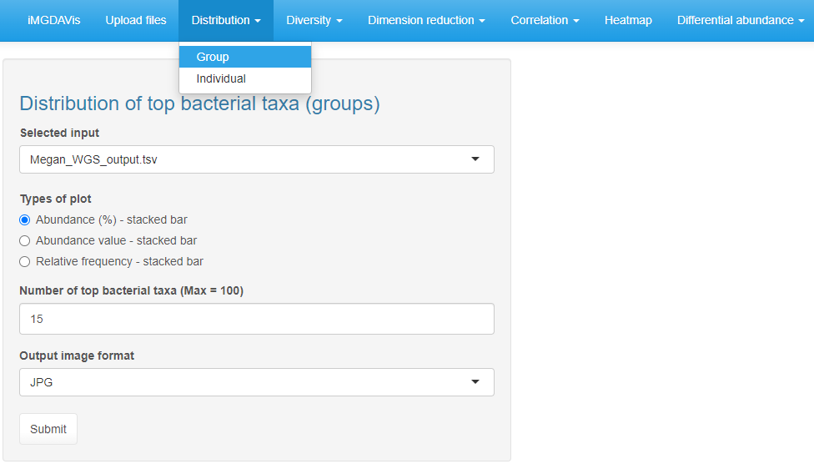

Select file formats (JPG, TIFF, PDF, SVG, BMP, EPS, and PS)

Select upto two to 100 taxa’s (default is 15)

Selected file based on the input

Subsections

Different types of plots

**Figure S8**: Input selection for group distribution

**Downloading images in various formats**

Users can download the figure with preferred dimensions up to 49 inches of height and weight in multiple image formats (JPG, TIFF, PDF, SVG, BMP, EPS, and PS) to download the result in publication quality and the journal with a recommended size and dpi (resolution: 72 to 1000). This menu was incorporated into all the tabs, which contain figures.

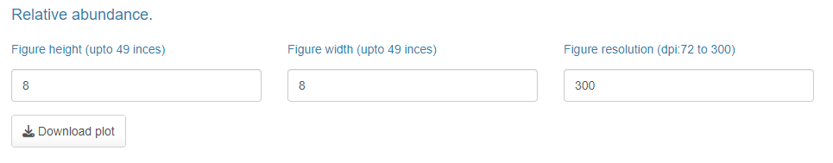

**Figure S9**: Download the plot in preferred dimensions for publication in multiple image formats.

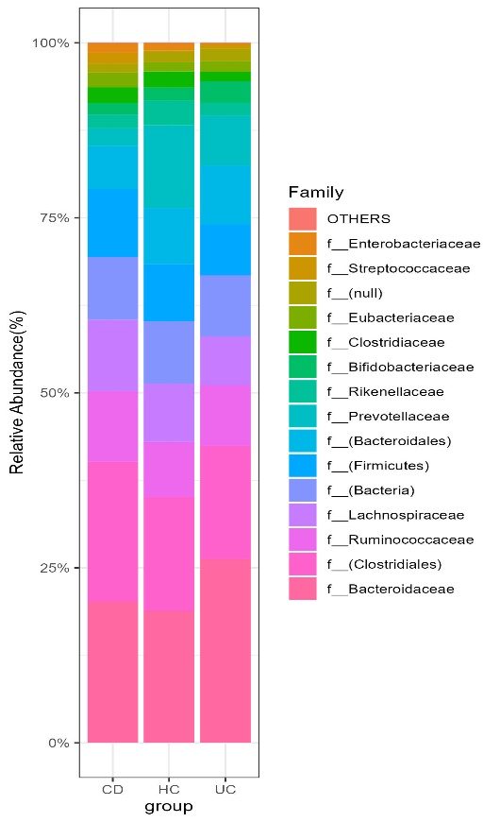 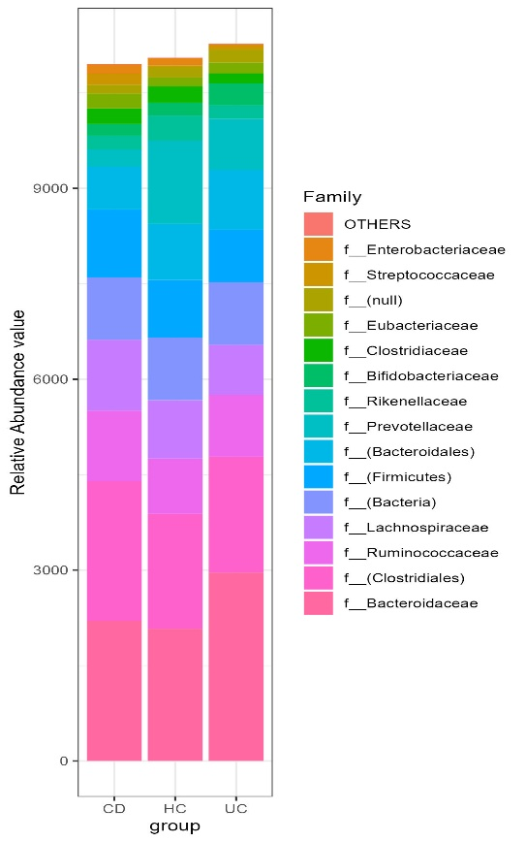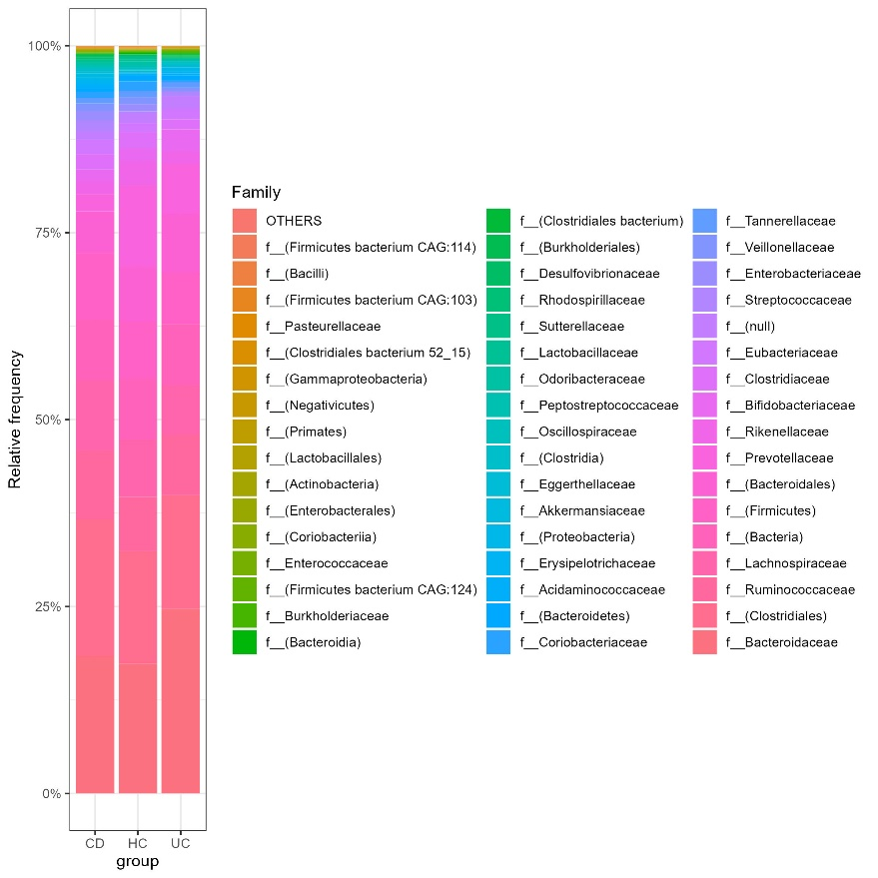

(b)

(c)

(a)

**Figure S10**: displays the top a) 15 relative abundance percentages, b) 15 relative abundance values, c) 50 relative abundance frequencies grouped by the list of conditions in metadata

**Distribution based on induvial:**

Users need to select the plot types, no. of bacterial taxa to display, image output format, and click the submit button to visualize the plot (**Figure S11 – S12**).

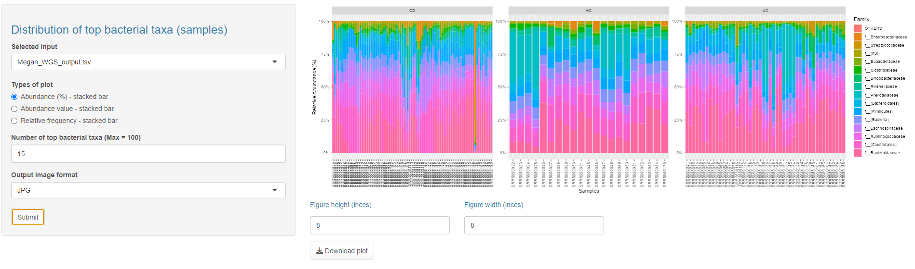

Select file formats (JPG, TIFF, PDF, SVG, BMP, EPS, and PS)

Select upto two to 100 taxa’s (default is 15)

Selected file based on the iput

Different types of plots

**Figure S11**: Input selection for individual distribution

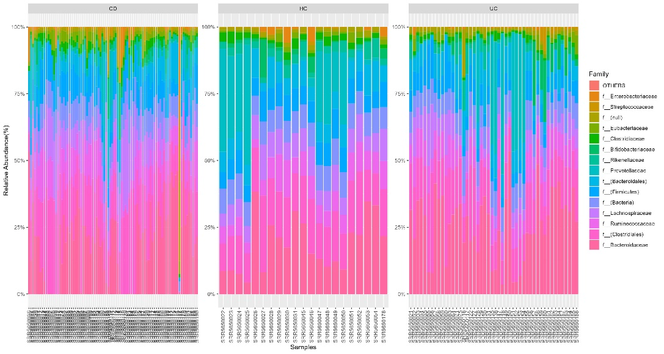

(b)

(a)

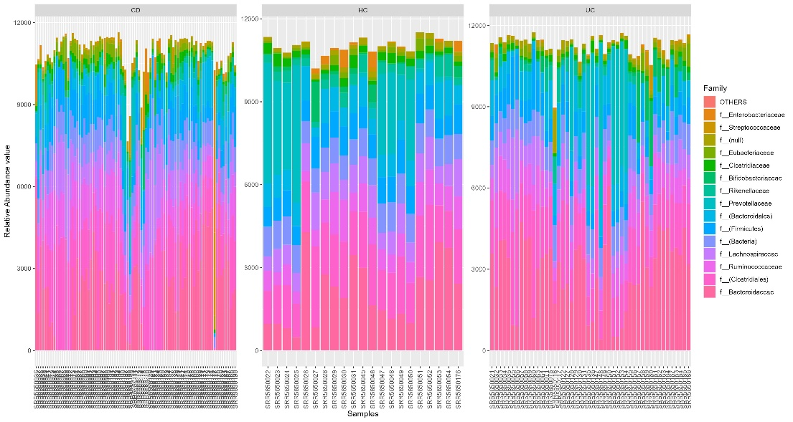

(c)

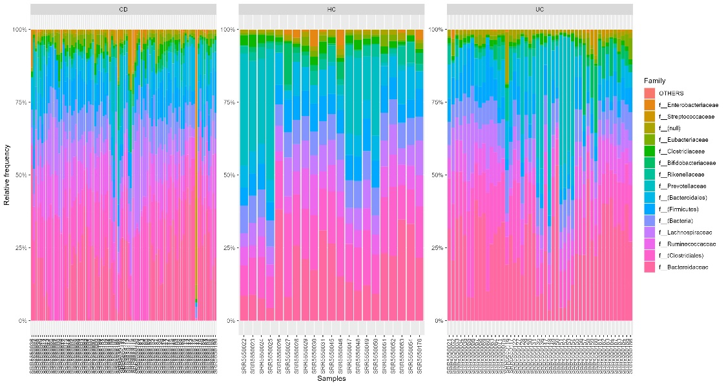

**Figure S12**: displays the top 15 a) relative abundance percentages, b) relative abundance values, c) relative abundance frequencies for the given samples in metadata

**Diversity**

Under the distribution tab, there are two subsections (**Figure S13**): 1. Alpha and 2. Beta diversity.

**Alpha diversity**

Alpha diversity was calculated by the phyloseq package (McMurdie and Holmes, 2013). Users can visualize the alpha diversity by choosing any one of the methods (**Figure S13**), such as Observed, Chao1(**Figure S14 a**), ACE, Shannon(**Figure S14 b**), Simpson, Inverse Simpson, Fisher or All_combined (combined all the listed methods)(**Figure S14 c**). The users can also get the diversity plot with the p-values (either values or *) (**Figure S14 d**), using Wilcoxon tests (from the microbiomeutilities package) (Shetty and Lahti, 2022) considering each pair of groups. Once the output plot types and the image format are selected, then click the submit button to calculate diversity. Users can also get the alpha diversity for each sample by clicking the summary table tab (**Figure S15**).

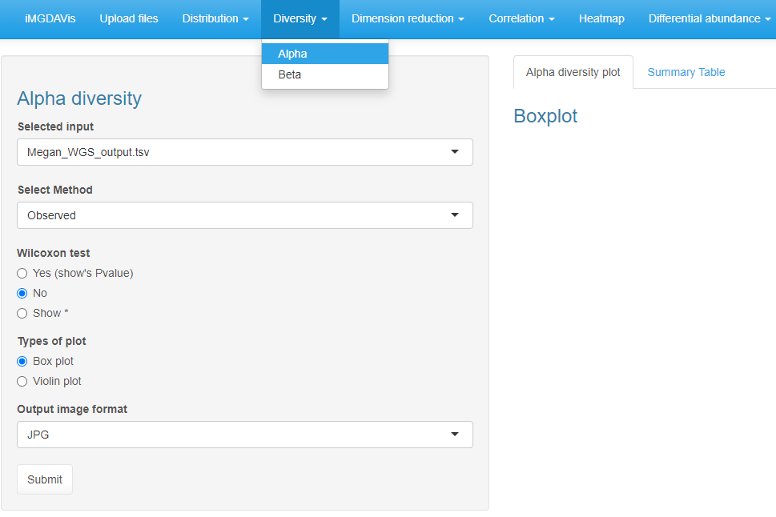

Subsection

Select file formats (JPG, TIFF, PDF, SVG, BMP, EPS, and PS)

Observed, Chao1, ACE, Shannon, Simpson, Inverse Simpson, Fisher or All_combined (combined all the listed methods)

("****", "***", "**", "*", "ns")

(0, 0.0001, 0.001, 0.01, 0.05, Inf)

Different types of plot

**Figure S13**: Input selection for alpha diversity

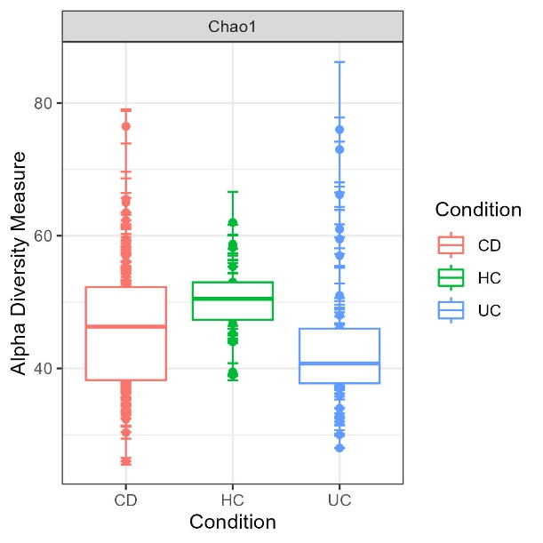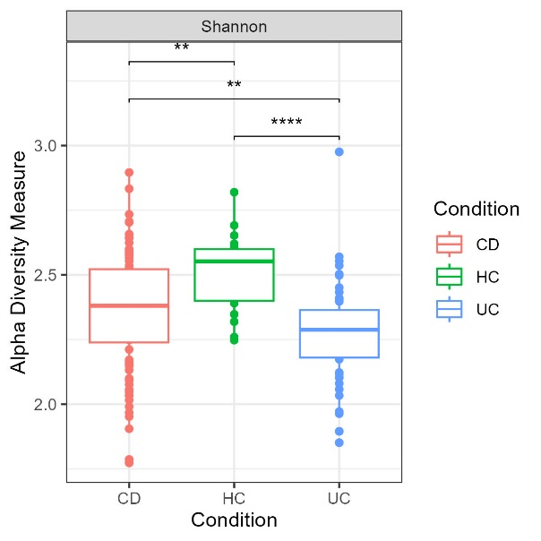

(c)

(b)

(a)

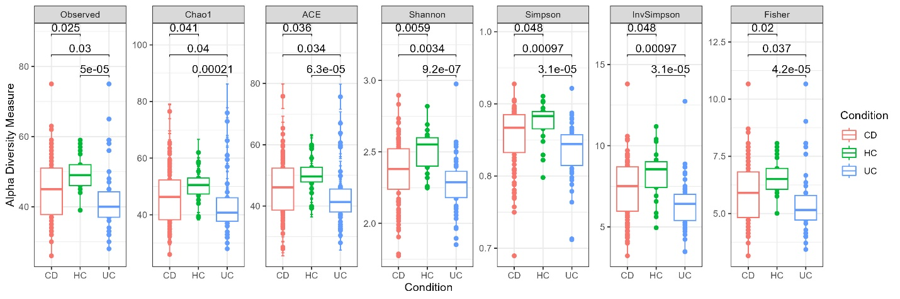

(d)

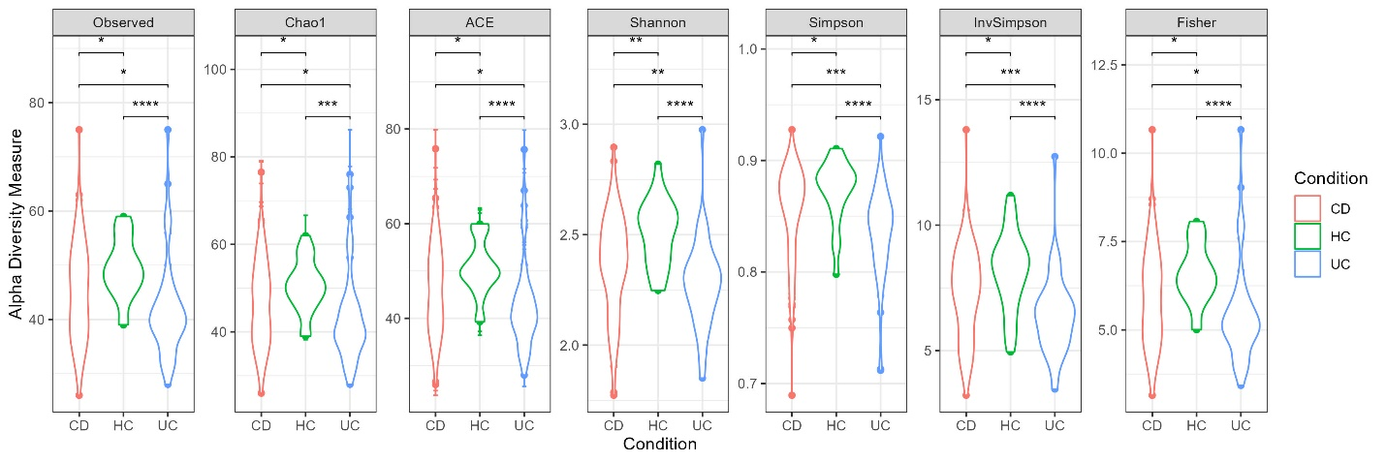

**Figure S14.** The box plot shows the alpha diversity, which is calculated based on the a) chao1 without p-value, b) Shannon index with p-value (shows: "****", "***", "**", "*", "ns"), c) using all the methods with p-value, d) Plotted in violin with p-value (shows: "****", "***", "**", "*", "ns").

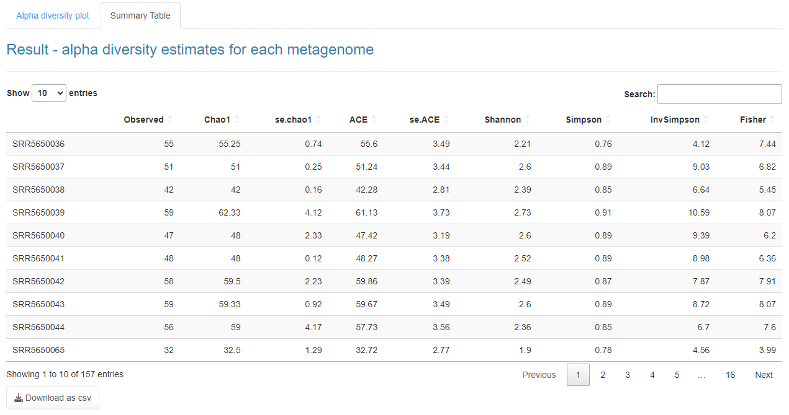

**Figure S15:** Summary table of alpha diversity for each sample

**Beta diversity**

Beta diversity was calculated based on phyloseq (unlist(distanceMethodList)) (McMurdie and Holmes, 2013) and vegan (Oksanen et al., 2017) packages. Users can visualize the alpha diversity by choosing any one of the methods. In our application, we have integrated 42 distance metrics. Users can use any one of the following methods such as (bray, jaccard, manhattan, euclidean, canberra, kulczynski, gower, altGower, morisita, horn, mountford, raup, binomial, chao, cao, w, -1, c, wb, r, I, e, t, me, j, sor, m, -2, co, cc, g, -3, l, 19, hk, rlb, sim, gl, z, maximum, binary and minkowski) (**Figure S16**). In addition, we have incorporated six different orientation methods using the vegan package, such as (PCoA, NMDS, DCA, CCA, RDA, and MDS) (**Figure S16**). The result will be displayed in the box (**Figure S17 a**)and orientation plot (**Figure S17 b**) with the summary table (**Figure S18**), which contains distance matrics between all the samples.

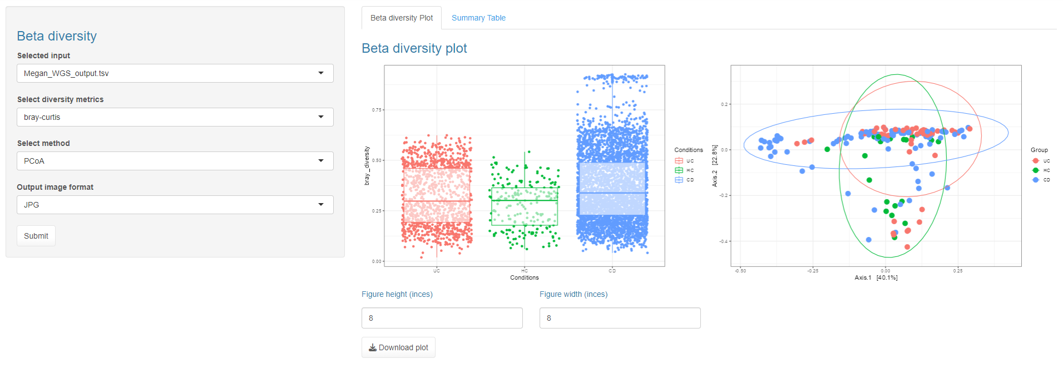

Select file formats (JPG, TIFF, PDF, SVG, BMP, EPS, and PS)

Select orientation methods (PCoA, NMDS, DCA, CCA, RDA, and MDS) (JPG, TIFF, PDF, SVG, BMP, EPS, and PS)

Select distance metrics (bray, jaccard, manhattan, euclidean, canberra, kulczynski, gower, altGower, morisita, horn, mountford, raup, binomial, chao, cao, w, -1, c, wb, r, I, e, t, me, j, sor, m, -2, co, cc, g, -3, l, 19, hk, rlb, sim, gl, z, maximum, binary and minkowski)

**Figure S16**: Input selection for beta diversity

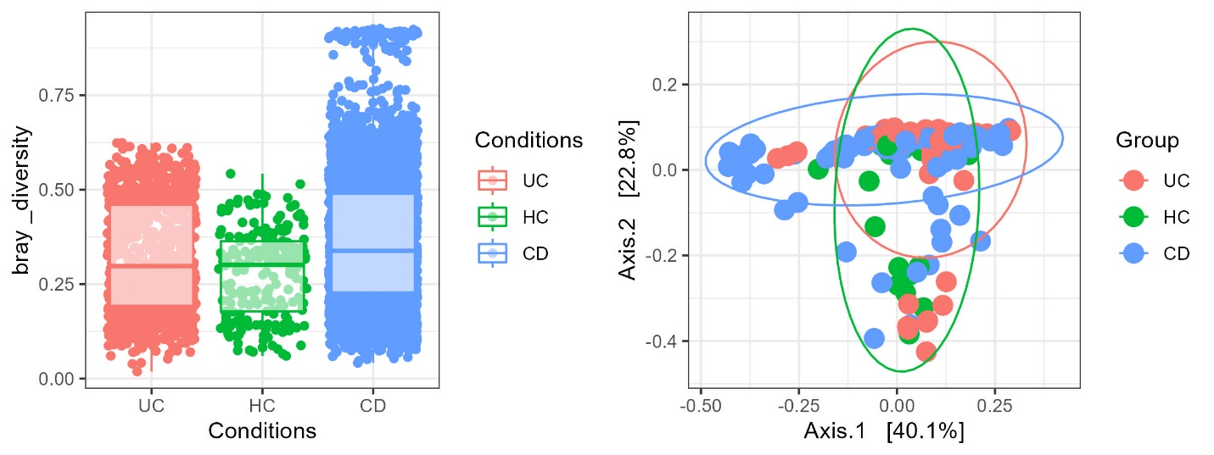

(a)

(b)

**Figure S17** a) The diversity metrics (bray) were plotted in the box plot b) the diversity matrics (bray) with PCoA orientation were plotted.

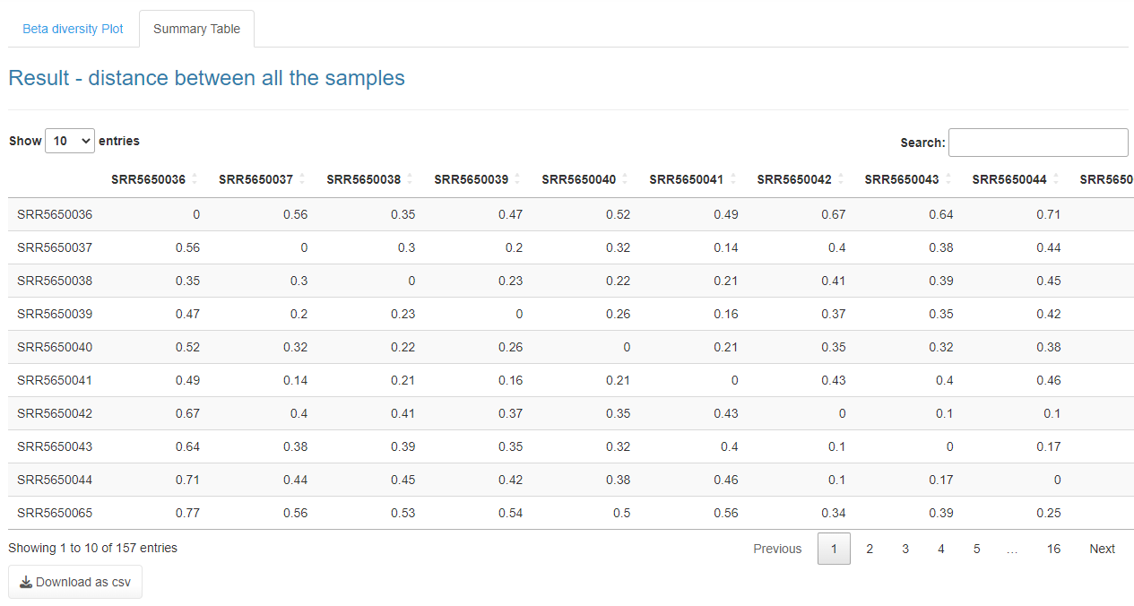

**Figure S18:** Summary table of beta diversity

**Dimension reduction**

Under this tab, there are three subsections (**Figure S19**) 1. Principal Component Analysis (PCA) 2D and 3D, 2. t-distributed Stochastic Neighbor Embedding (t-SNE) and 3. Uniform Manifold Approximation and Projection for Dimension Reduction (UMAP).

**PCA-2D & 3D**

The ggfortify (Tang et al., 2016) was used to plot the PCA-2D. The users must select the text label and its size, frame, and output image format and click the submit button (**Figure S19**). The output will be displayed in a PCA-2D plot (**Figure S20**) with a summary table (**Figure S21**). For the PCA-3D plot, we used plotly to create the plot. In this section, the user must click the submit button to see the PCA plot in 3D. The plotly has its function to export the image in png format (**Figure S22**). The PCA summary table contains the PC1, PC2 and PC3 coordinates (**Figure S23**).

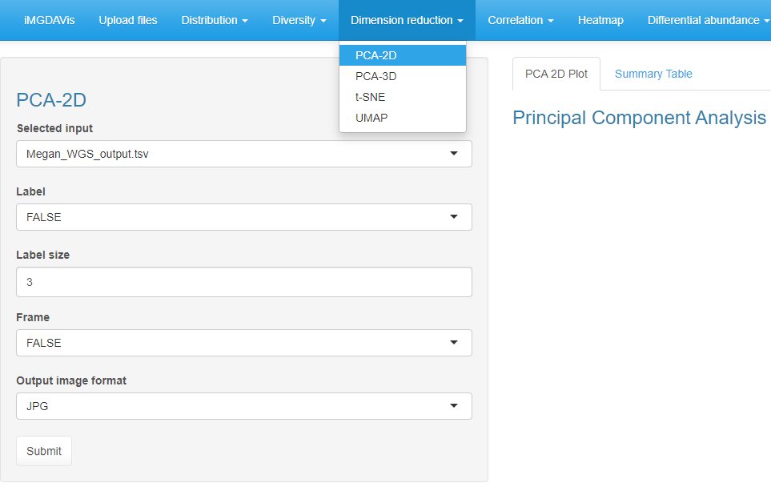

If true display circular frames

Select file formats (JPG, TIFF, PDF, SVG, BMP, EPS, and PS)

Sample label size

If true it will display sample labels

Subsection

**Figure S19**: Input selection for PCA plot.

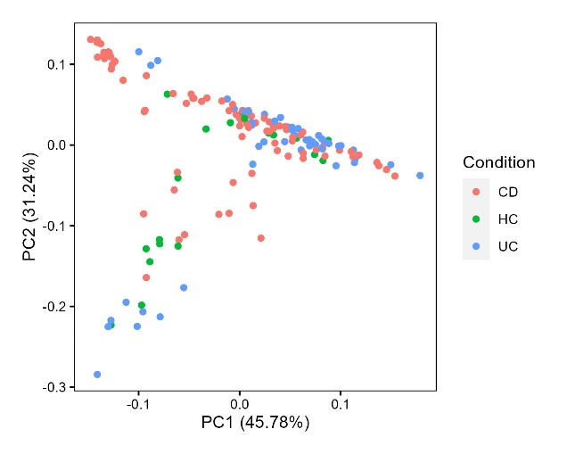 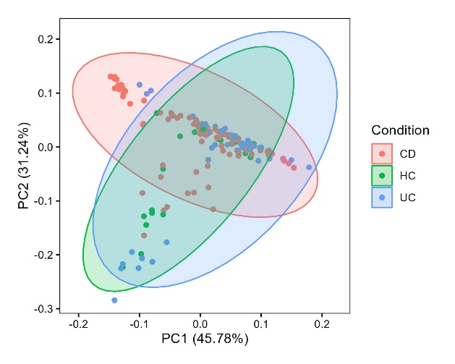

(b)

(a)

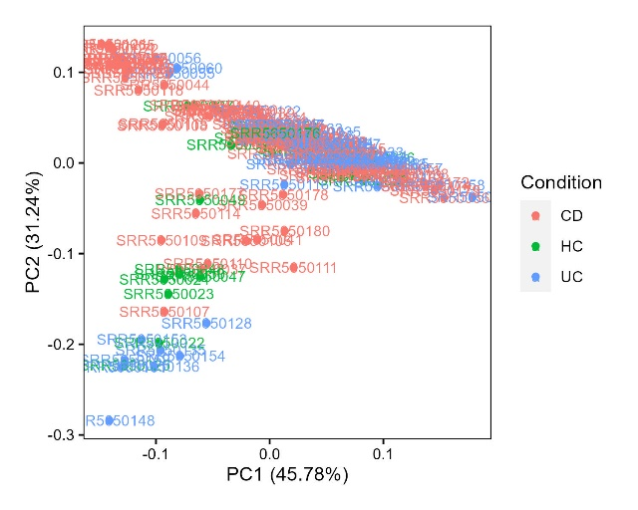 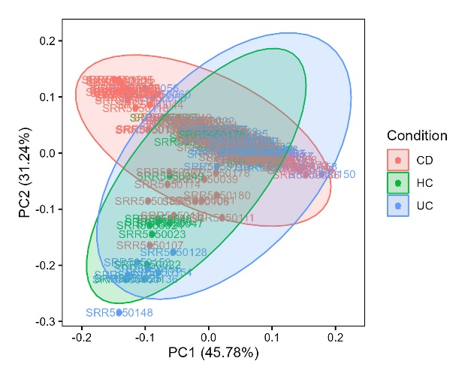

(d)

(c)

**Figure S20.** DisplaysPCA-2D plot with a) no labels and no frame, b) no labels and with a frame, c) with labels and no frame, d) with labels and frame.

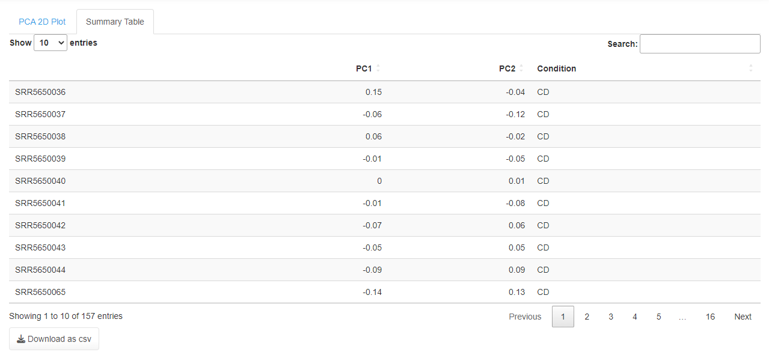

**Figure S21.** Summary table for PCA. Each sample coordinate position was shown in PC1 and PC2.

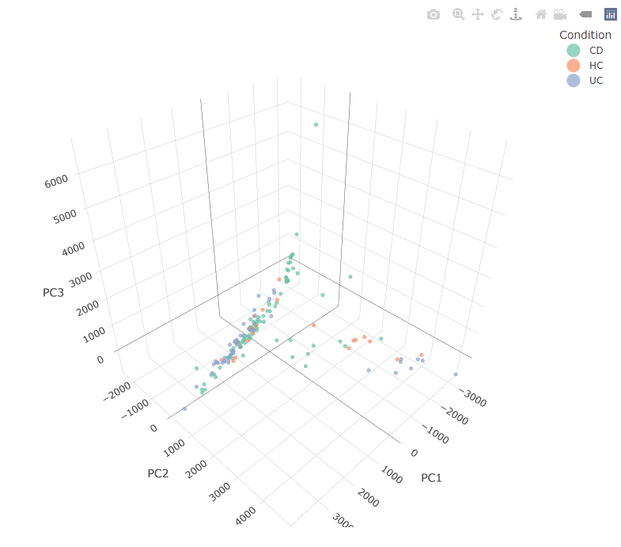

**Figure S22.** DisplaysPCA-3D plot. Plotly provides a default menu option in the top-right corner to export the plot.

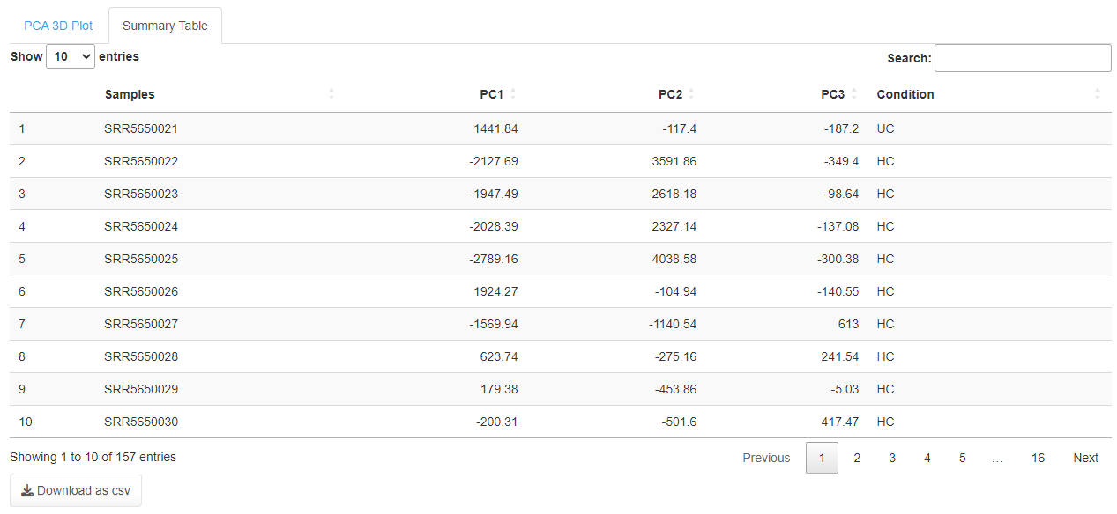

**Figure S23.** Summary table for PCA-3D. Each sample coordinate position was shown in PC1, PC2 and PC3.

**t-SNE**

The t-SNE was plotted using a scater package (McCarthy et al., 2017). We have incorporated six methods from the scater to plot the t-SNE: counts, rclr, hellinger, pa, rank, and relabundance in two and three dimension orientations (**Figure S24**). After selecting methods, orientation and output image format, click submit to visualize the t-SNE plot (**Figure S25 a & b**)and their summary tables (**Figure S26 a & b**).

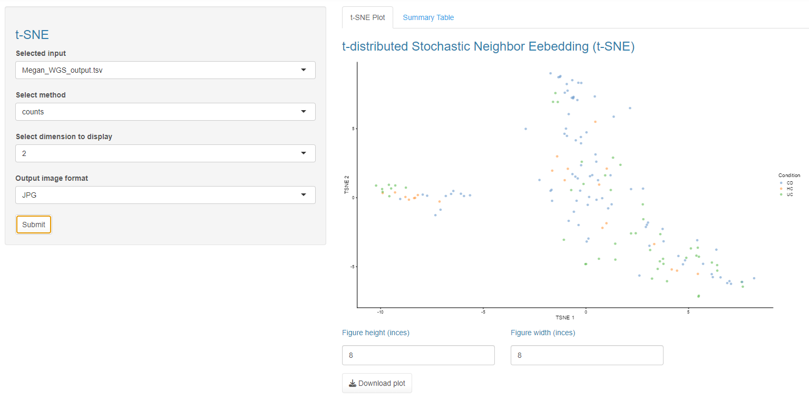

Select file formats (JPG, TIFF, PDF, SVG, BMP, EPS, and PS)

Select dimension (2 or 3)

Select method (counts, rclr, hellinger, pa, rank, and relabundance)

**Figure S24**: Input selection for t-SNE plot

(b)

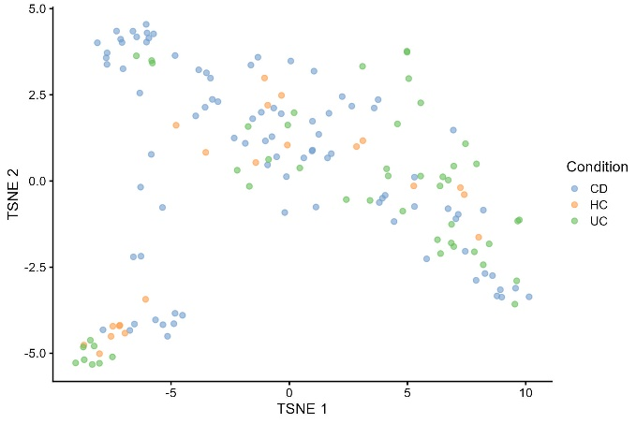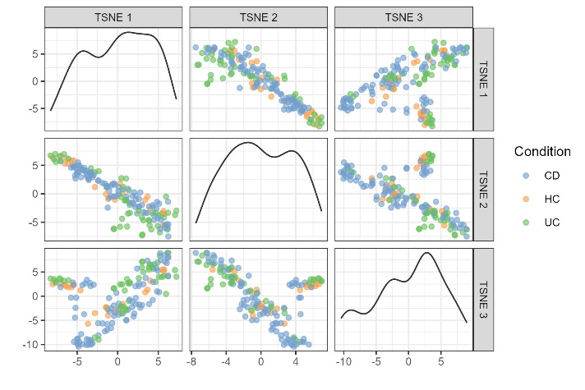

(a)

**Figure S25**. Thet-SNE plot in a) two dimensions, b) three dimensions

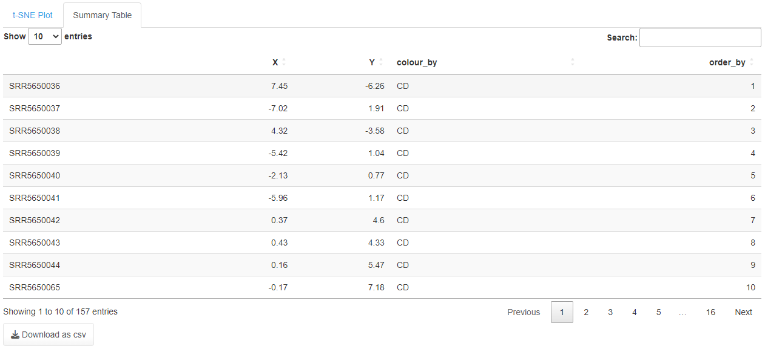

(b)

(a)

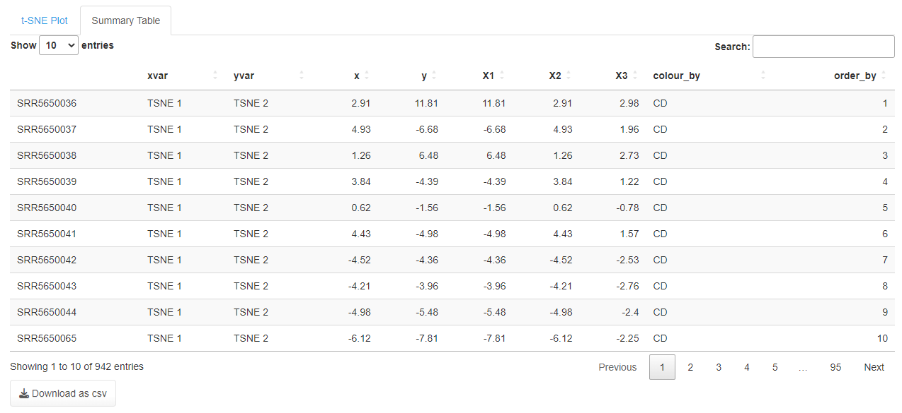

**Figure S26.** Summary table for t-SNE a) two dimensions, b) three dimensions

**UMAP**

The UMAP was incorporated using two packages, scater (McCarthy et al., 2017) and bluster (Lun, 2022). We have incorporated six methods from the scater to plot the UMAP: counts, rclr, hellinger, pa, rank, and relabundance. The cluster package was used to plot the graph using cluster-based with the selected k-value (**Figure 27**). After selecting methods, k-value and output image format, click submit to visualize the UMAP plot (**Figure S28 a & b**)and their summary tables (**Figure S29 a & b**).

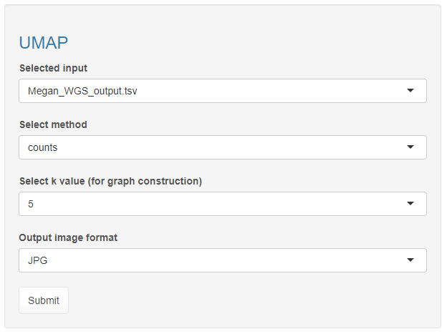

Select file formats (JPG, TIFF, PDF, SVG, BMP, EPS, and PS)

K-value (2 to 15)

Select method (counts, rclr, hellinger, pa, rank, and relabundance)

**Figure S27**: Input selection UMAP plot

(b)

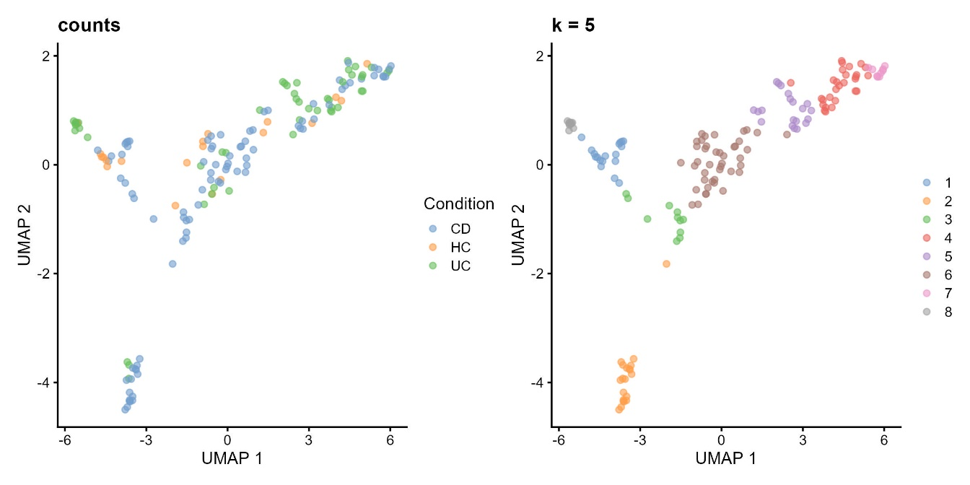

(a)

**Figure S28.** a) UMAP plot based on the selected method (counts), colored by Condition from metadata, b) Plot colored based on cluster-based using the selected K-value

(a)

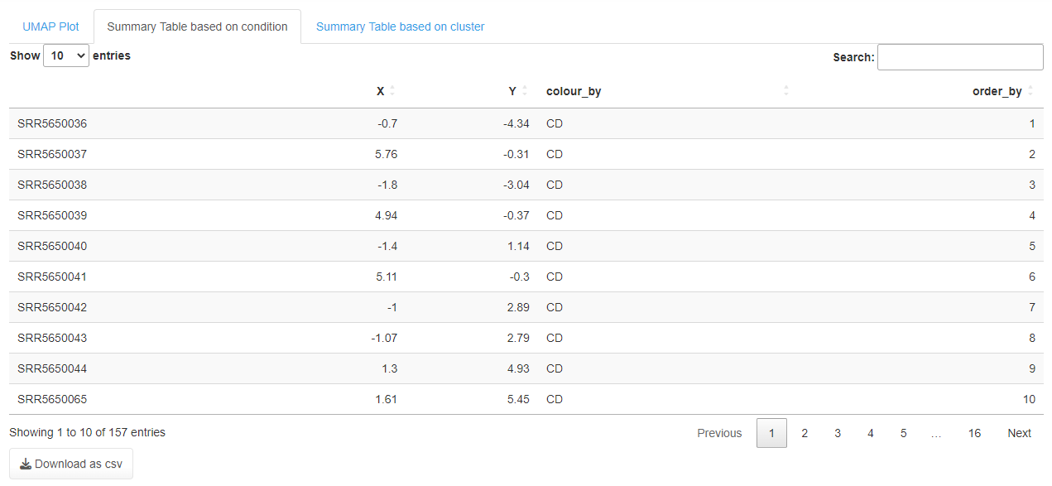

(b)

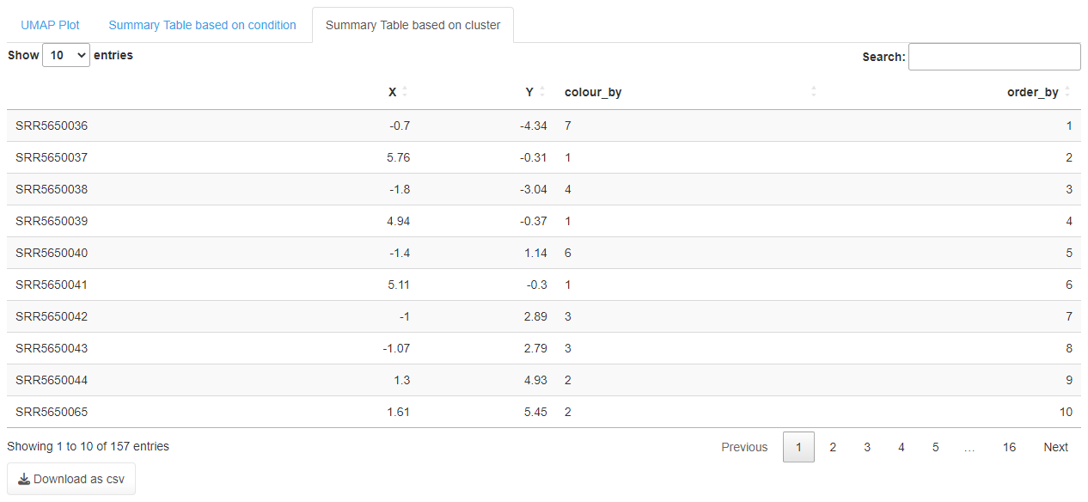

**Figure S29.** Summary table for UMAP based on a) conditions from metadata using the selected method (counts), b) Cluster-based using K-value

**Correlation analysis**

Under this tab are two subsections: 1) Taxa-based and 2) Sample-based correlation (**Figure S30**)**.**

**Taxa-based correlation**

The taxa-basedcorrelation plot was incorporated using the GGally (Schloerke et al., 2022) package with the ggcorr function to call three different methods: pearson, kendall and spearman. Once the method, label size and output format are selected, click submit (**Figure S30**) to visualize the taxa plot (**Figure S31**)and summary table (**Figure S32**)for the selected taxonomy on the file upload page. We have used ggpubr (Kassambara 2022) to do our graphics.

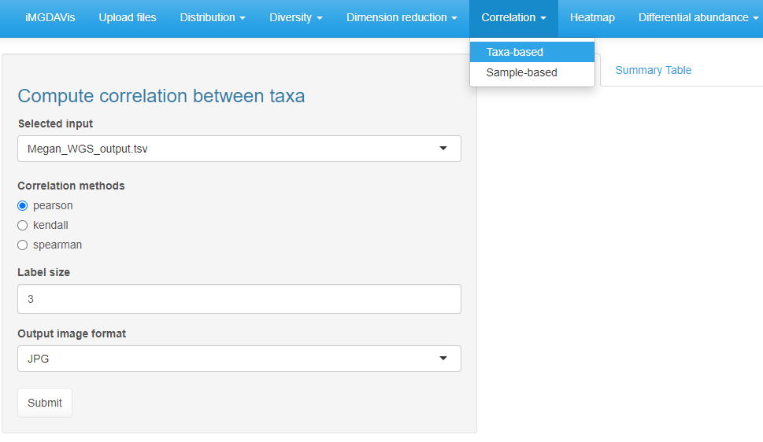

Subsection

Methods used for analsysis

Enter the font size to display the sample labels

Select file formats (JPG, TIFF, PDF, SVG, BMP, EPS, and PS)

**Figure S30**. Input selection for taxa-based correlation analysis

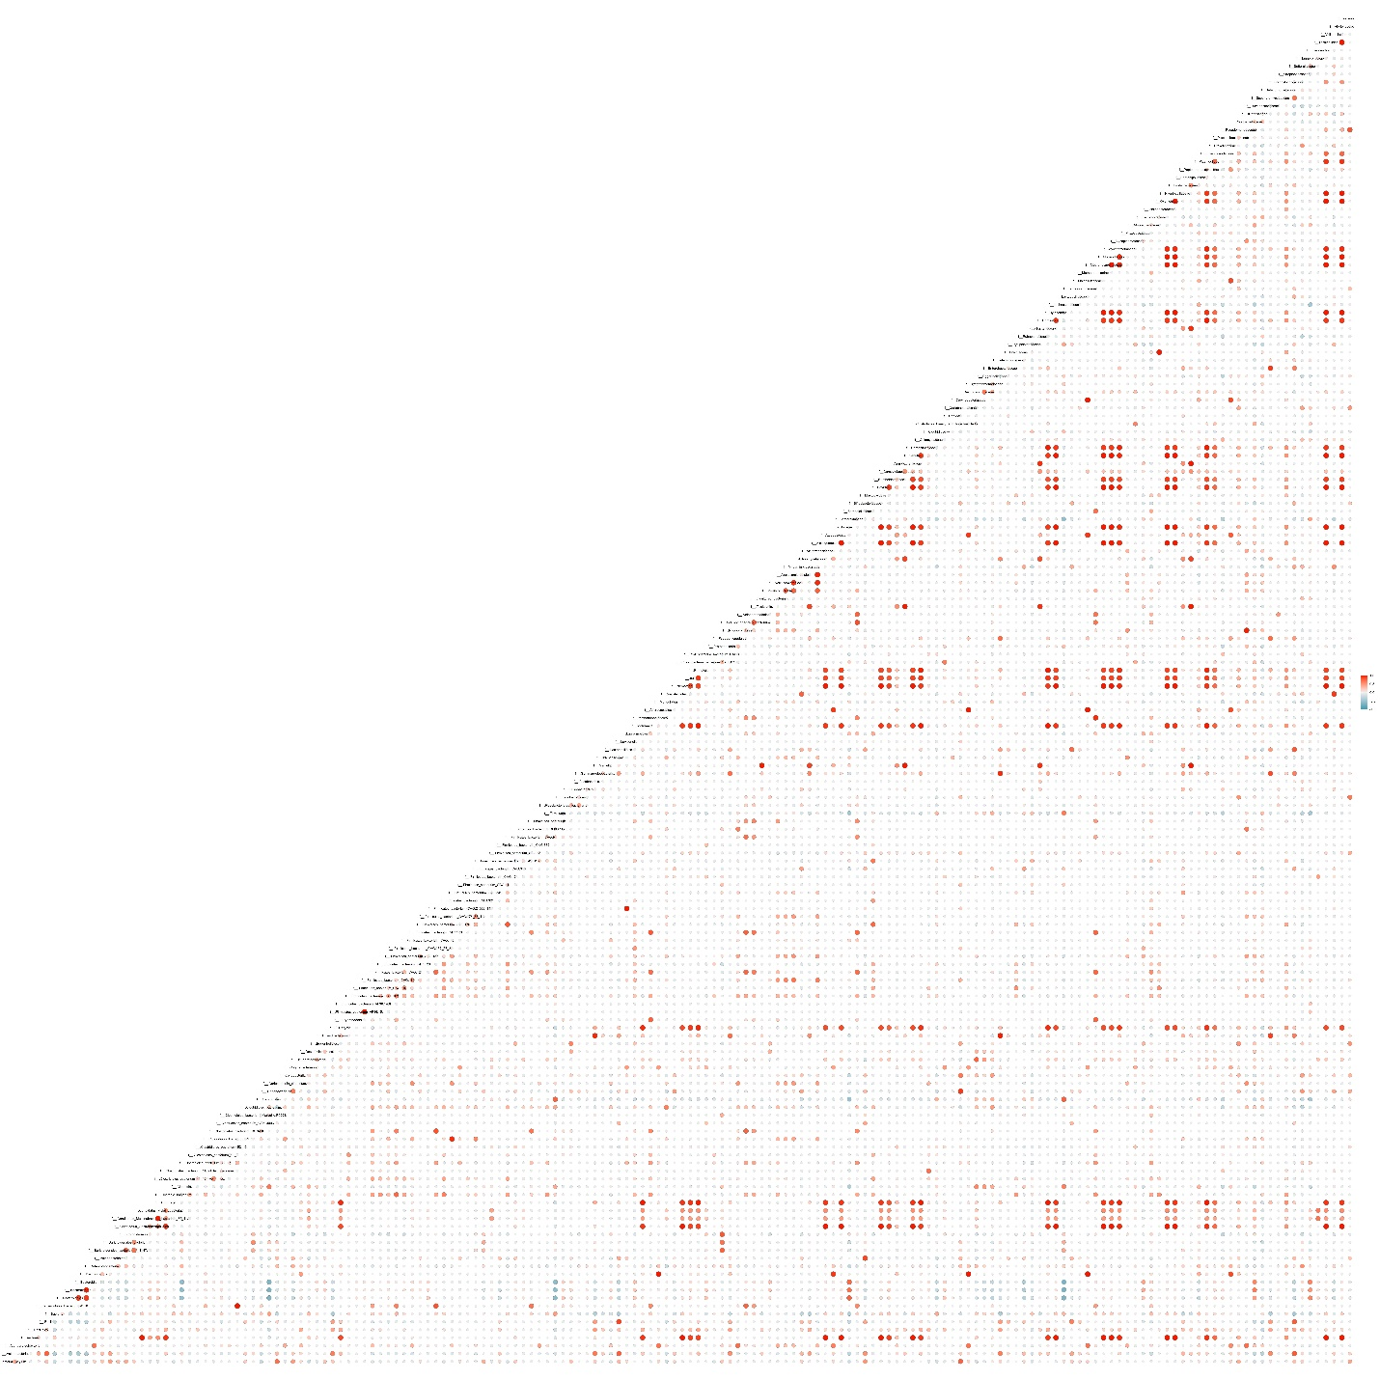

**Figure S31**. Taxa-based correlation plot using the pearson method

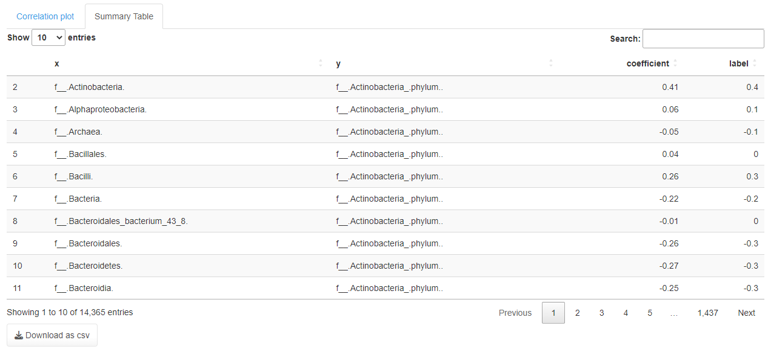

**Figure S32**. Taxa-based correlation table using the pearson method

**Sample-based correlation**

The sample-basedcorrelation plot was incorporated with a similar method used for taxa-based correlation. Once the method, label size and output format are selected, click submit (**Figure S33**). It will display the correlation plot for samples provided in the metadata (**Figure S34**)and the summary table (**Figure S35**).

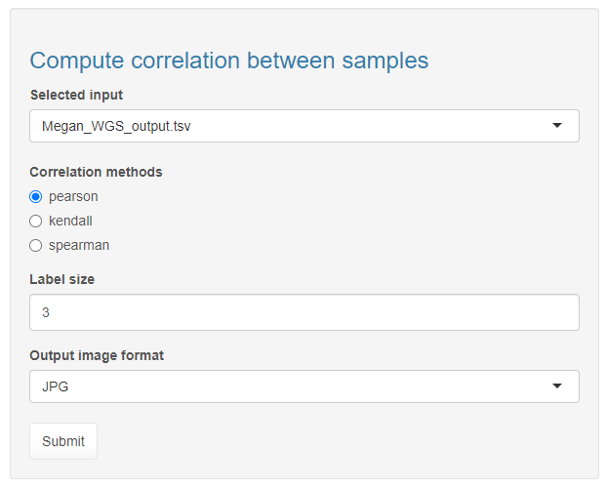

Methods used for analysis

Select file formats (JPG, TIFF, PDF, SVG, BMP, EPS, and PS)

Enter the font size to display the sample labels

**Figure S33**. Input selection for sample-based correlation analysis

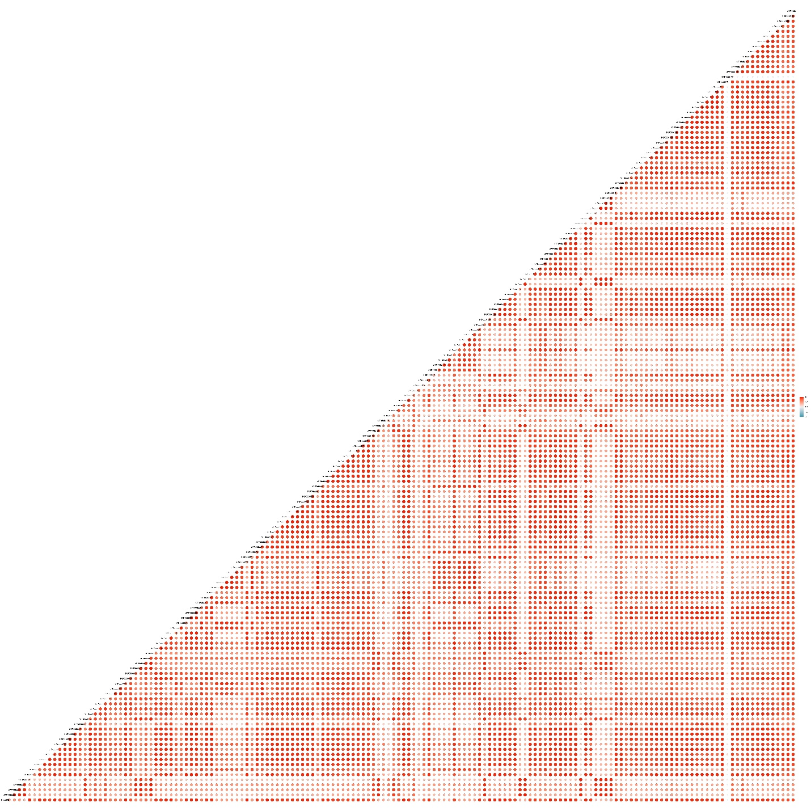

**Figure S34**. Sample-based correlation plot using the pearson method

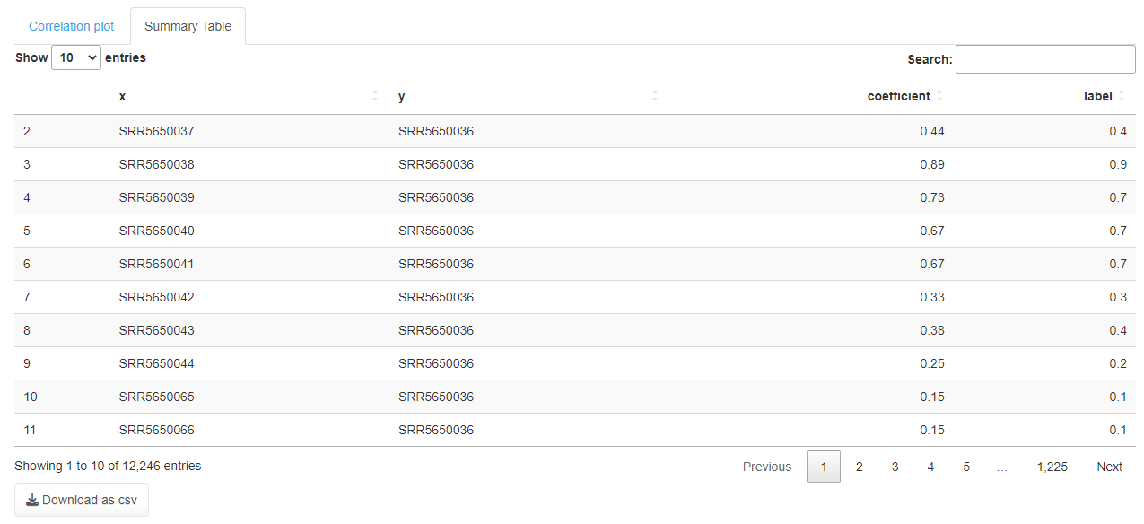

**Figure S35**. Sample-based correlation table using the pearson method

**Heatmap**

The heatmap was generated with ComplexHeatmap (Gu, 2022), scales (Wickham and Seidel, 2022) and ggplotify. The user modifies the heatmap according to their needs by selecting the label names, text size, and cladogram (**Figure S36**). Then select the output format and click the submit button to visualize the heatmap (**Figure S37**).

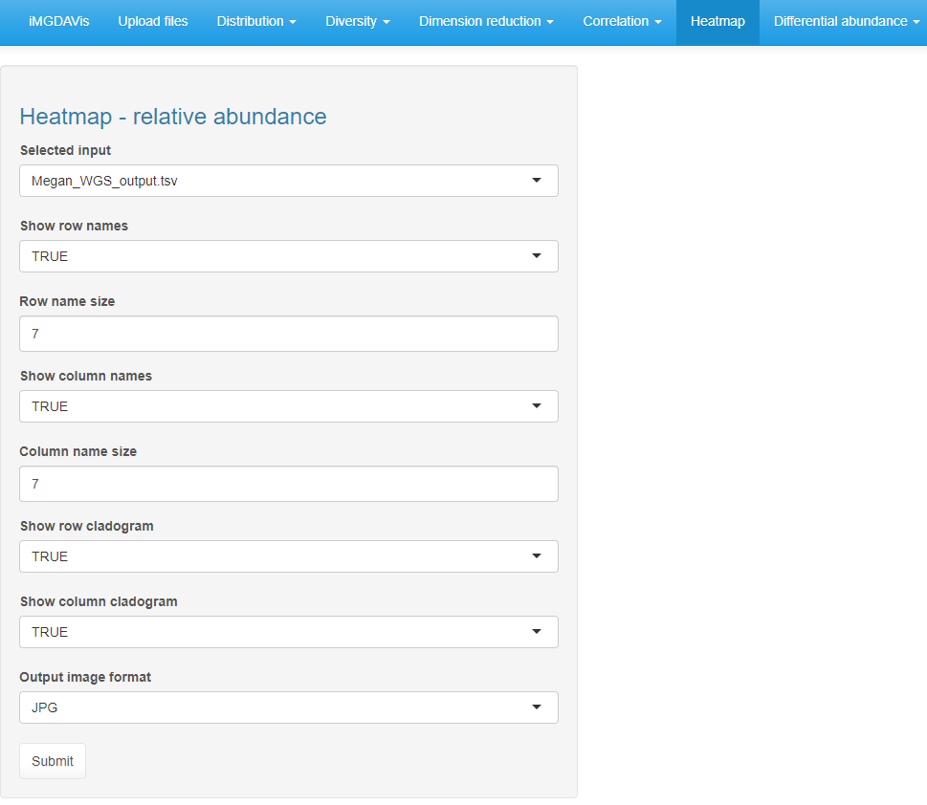

Select file formats (JPG, TIFF, PDF, SVG, BMP, EPS, and PS)

If true display column cladogram

If true display row cladogram

Size of the column names

If true display column names

Size of the row names

If true display row names

**Figure S36**. Input selection for heatmap analysis

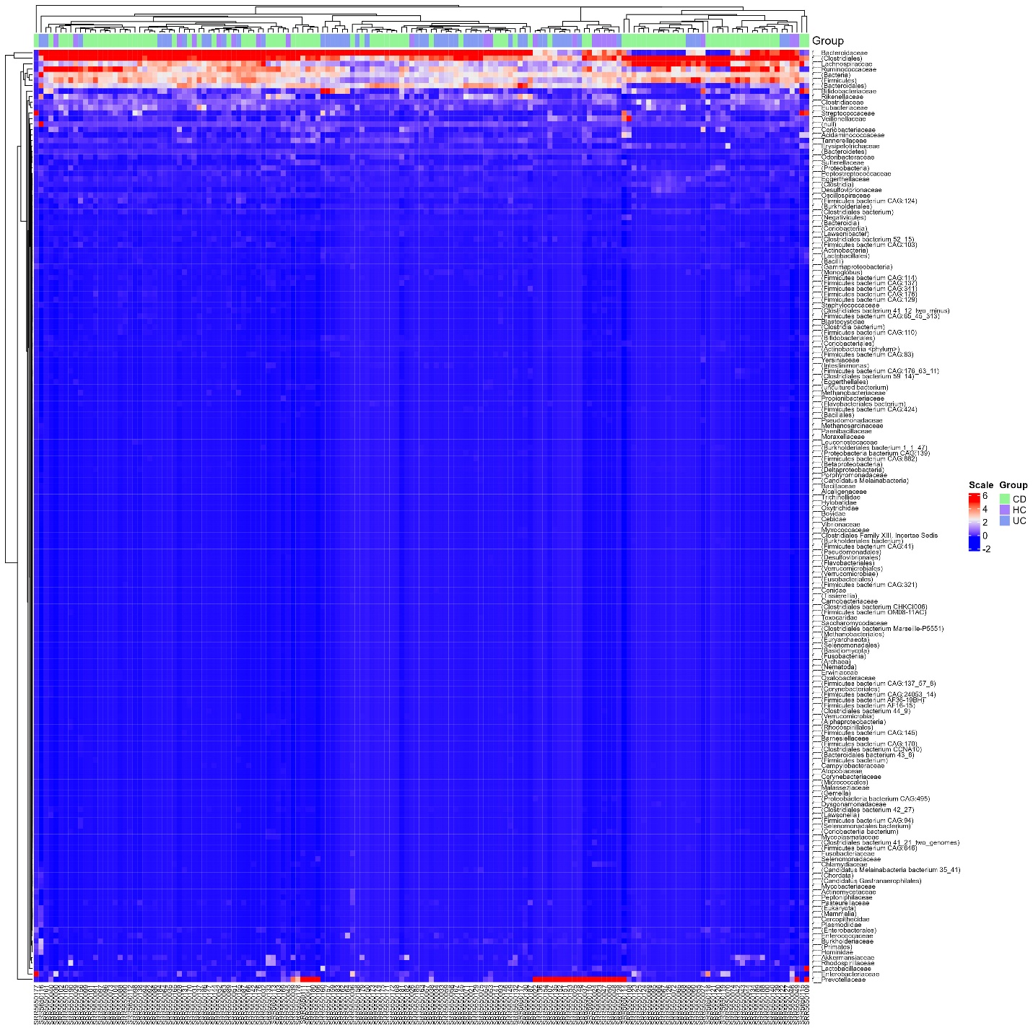

**Figure S37**. The heatmap for the selected taxonomy level on the upload page shows sample names in rows and family names in columns with a cladogram. Scale values represent the colors in the heatmap and groups represent the no. of conditions in the metadata file

**Differential abundance**

In differential abundance, we have two subsections: Two groups and Multiple groups (**Figure S38**).

**Two groups**

The two group methods analyze one set of control and case samples from the metadata. To analyze the metagenome data, we have incorporated six different methods: Wilcoxon Rank Sum test, t-test: Two sample t-test, metagenomeSeq (Paulson et al., 2013), DESeq2 (Love et al., 2016), Limma-Voom (Ritchie et al., 2015) and edgeR (Robinson et al., 2010) (**Figure S38**). For the Wilcoxon Rank Sum test (wilcox.test) and t-test (t.test) statistical analysis, we have converted the raw count value to relative frequency using the formula (**Relative Frequency =** (**Subgroup frequency/ Total frequency**) **\*100**)). For metagenomeSeq, DESeq2, Limma-Voom and edgeR, we have used their package algorithm to find the significant taxonomy.

Users must select two different conditions in 1 and 2 (it was a pop-up based on your metadata file, which you uploaded on the upload page). This section uses only two groups for the comparison (HC vs. CD). Then, users need to select the test correction method, either Benjamini-Hochberg FDR or P-value; also, they can adjust the FDR or P-value based on their needs (default is < 0.05). Finally, select any plot type and image format, then click the submit button (**Figure S38**) to visualize the grouped box plot (**Figure S39a**), individual box blot for each taxon (**Figure S39b**), volcano plot (**Figure S39c**) and the heatmap of significantly identified taxa (**Figure S39d**)**.** We have similar input methods for all these six methods, and similar plots will be generated. Only the summary tables (**Figure S40**)columns will differ (**Table 2**).

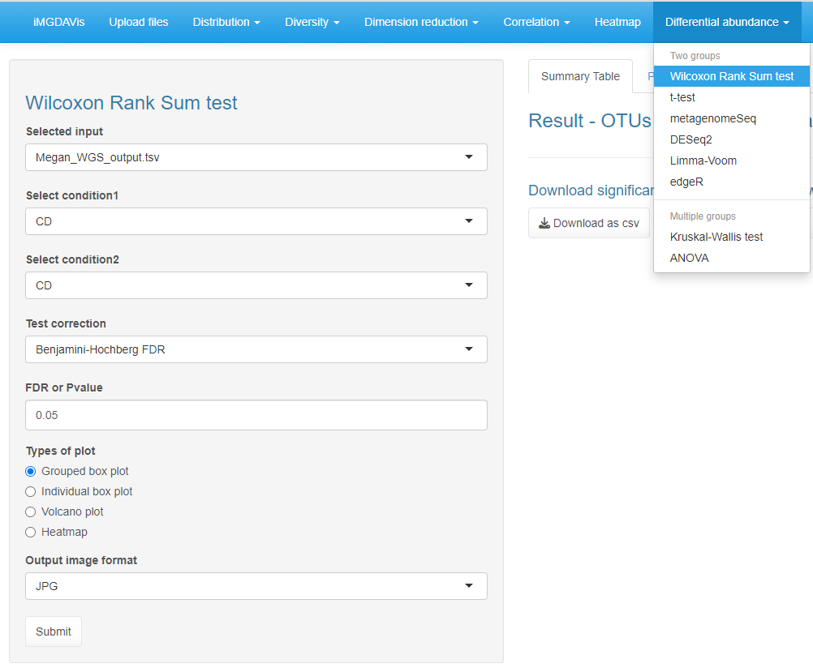

Select file formats (JPG, TIFF, PDF, SVG, BMP, EPS, and PS)

User can adjust the value based on their needs

Select Benjamini-Hochberg FDR or P-value

Select two different conditions in 1 and 2

Select plot type to display

Subsection

**Figure S38**. Input selection for the Wilcoxon Rank Sum test and similar input is needed for the remaining methods

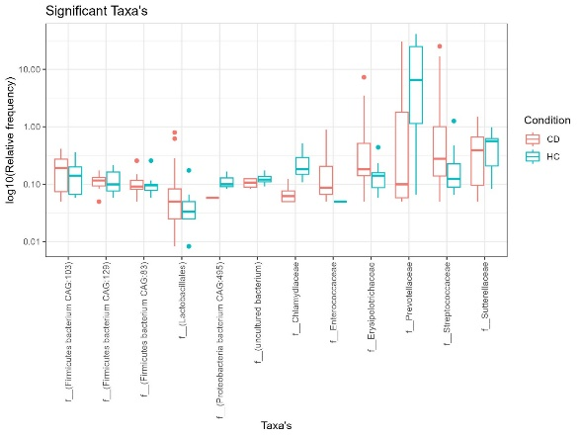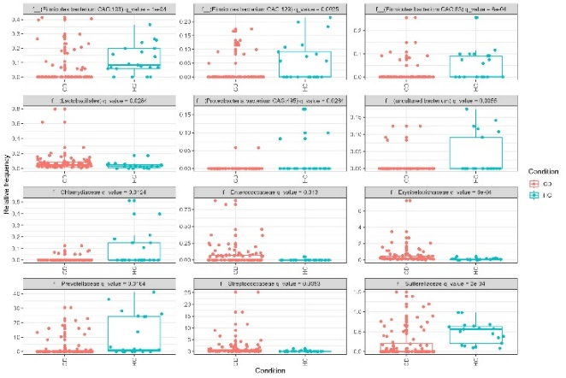

(d)

(c)

(b)

(a)

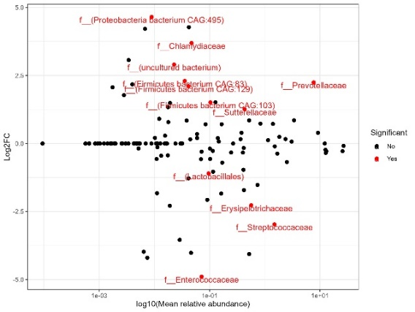 

**Figure S39**.Taxa were identified as significant by using the Wilcoxon Rank Sum test. The results were visualized in a) the grouped box plot; the x-axis represents the taxa and the y-axis represents the log10(relative frequency). b) An individual box plot for each taxon; the x-axis represents the Condition, the y-axis represents relative frequency, and c) the volcano plot; the x-axis represents the log10(mean relative abundance) and the y-axis represents Log2FC. d) the heatmap for significantly identified taxa. Likewise, similar plots were generated for the remaining methods.

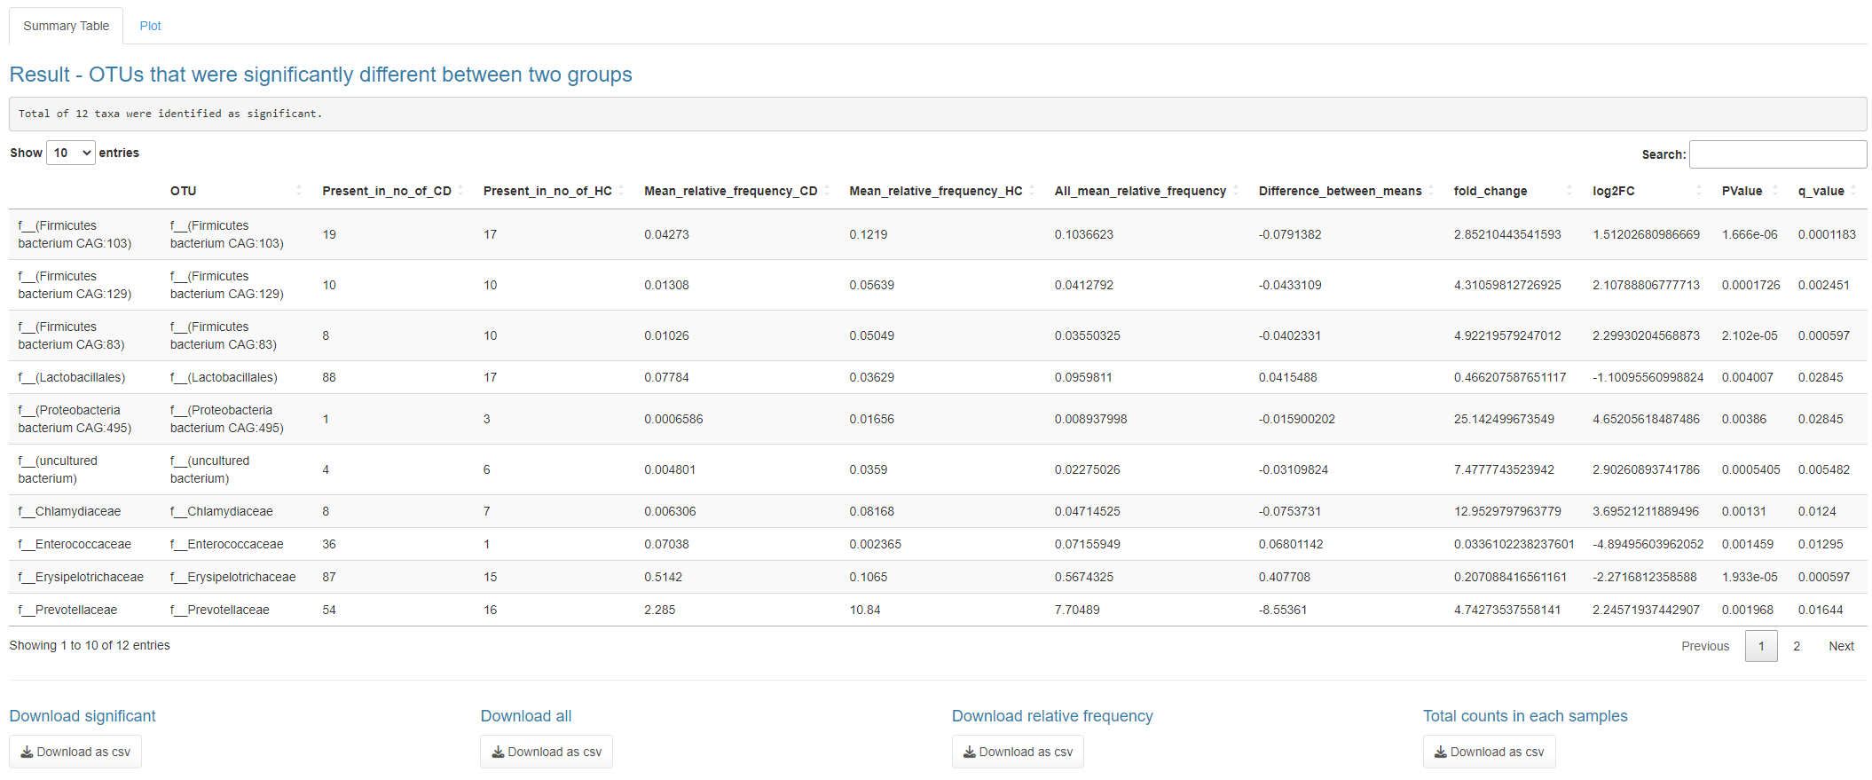

Export the summary tables in csv format

Statistically of significant taxa

Number of significant taxa

**Figure S40.** Summary table for the Wilcoxon Rank Sum test. Likewise, similar tables were generated for the remaining methods.

**Table S2.** Output table column for the significant taxa by using various methods

|  |  |  |  |  |  |  |
| --- | --- | --- | --- | --- | --- | --- |
|  | **Wilcoxon Rank Sum test** | **t-test** | **metagenomeSeq** | **DESeq2** | **Limma-Voom** | **edgeR** |
| OUT (Taxa) | **✓** | **✓** | **✓** | **✓** | **✓** | **✓** |
| Present_in_no_of_CD (Condition1) | **✓** | **✓** | **✓** |  |  |  |
| Present_in_no_of_HC (Condition2) | **✓** | **✓** | **✓** |  |  |  |
| Counts_in_HC |  |  | **✓** |  |  |  |
| Counts_in_CD |  |  | **✓** |  |  |  |
| Mean /Mean_relative_frequency_CD (Condition1) | **✓** | **✓** |  |  | **✓** |  |
| Mean / Mean_relative_frequency_HC (Condition2) | **✓** | **✓** |  |  | **✓** |  |
| All_mean / All_mean_relative_frequency | **✓** | **✓** | **✓** | **✓** | **✓** |  |
| Difference_between_means | **✓** | **✓** |  |  |  |  |
| fold_change | **✓** | **✓** | **✓** | **✓** | **✓** | **✓** |
| log2FC | **✓** | **✓** | **✓** | **✓** | **✓** | **✓** |
| PValue | **✓** | **✓** | **✓** | **✓** | **✓** | **✓** |
| FDR or q_value | **✓** | **✓** | **✓** | **✓** | **✓** | **✓** |
| standard_error |  |  | **✓** |  |  |  |

**Multiple groups**

The multiple-group methods analyze more than two sets of conditions from the metadata, e.g. (Control, case1 and case2). In this tutorial, we have used Healthy control (HC), Crohn's Disease (CD) and Ulcerative Colitis (UC). To analyze the metagenome data, we have incorporated the Kruskal-Wallis test and ANOVA (Analysis of variance). The counts were converted to relative frequency, as mentioned above. Then we used the Kruskal-Wallis test (kruskal.test) and ANOVA (aov) function for statistical analysis. In addition, we also incorporated the Post-hoc test used to calculate the p-value for pairwise comparison between multiple groups, e.g. (CD vs. HC, CD vs. UC and HC vs. UC). For the Post-hoc test Dunn.test from dunn.test package used in the Kruskal-Wallis test. Likewise, TukeyHSD was used under ANOVA (**Figure S41**).

Users need to select the test correction method, either Benjamini-Hochberg FDR or P-value and the Post-hoc test; also, they can adjust the FDR or P-value based on their needs (default is < 0.05). Finally, select any plot type and image format, then click the submit button (**Figure S41**) to visualize the grouped box plot (**Figure S42a**), individual box blot for each taxon (**Figure S42b**) and heatmap (**Figure S42c**)**.** We have similar input methods for the ANOVA methods. It also generates similar plots and summary tables (**Figure S43**).

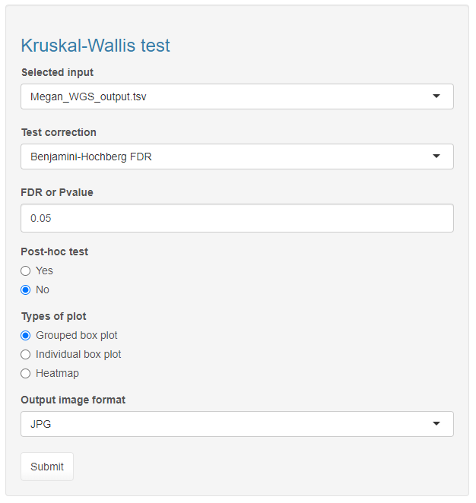

Select plot type to display

If yes perform pairwise comparison

Select file formats (JPG, TIFF, PDF, SVG, BMP, EPS, and PS)

Select Benjamini-Hochberg FDR or P-value

User can adjust the value based on their needs

**Figure S41**. Input selection for the Kruskal-Wallis test and similar input is needed for the ANOVA

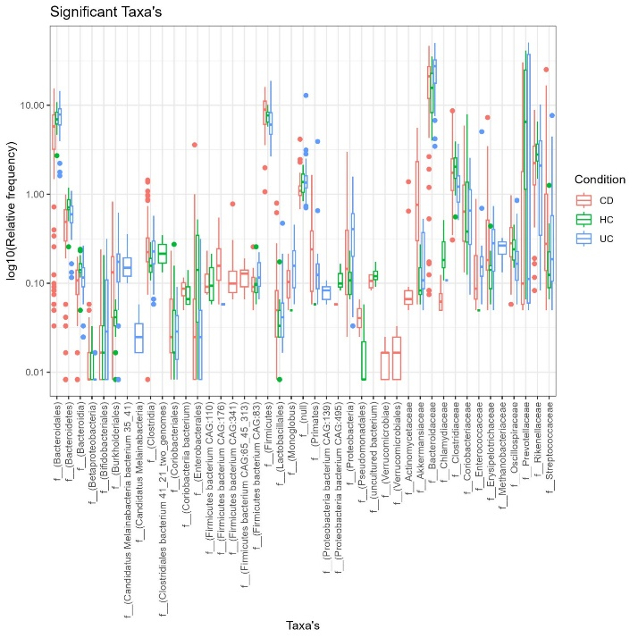 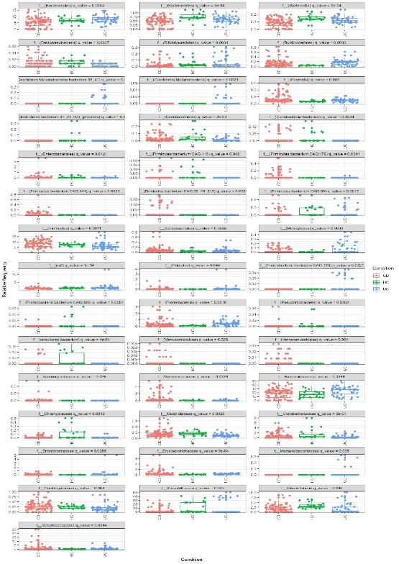

(b)

(a)

(c)

**Figure S42**.a) Taxa were identified as significant by using the Kruskal-Wallis test. The results were visualized in the grouped box plot in which the x-axis represents the taxa and the y-axis represents the log10(relative frequency). b) A box plot for each taxon in which the x-axis represents the Condition and the y-axis represents the relative frequency c) the heatmap for significantly identified taxa. Likewise, similar plots were generated for the remaining methods.

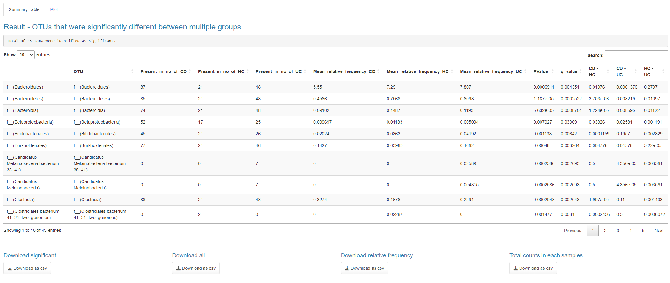

Number of significant taxa

Statistically of significant taxa

Export the summary tables in csv format

**Figure S43.** The summary table for the Kruskal-Wallis test. The last three columns contain the p-value of the pairwise comparison that will display if the Post-hoc test is selected as yes. Likewise, similar tables were generated for the ANOVA.

**Session information from R**

Here will a list of loaded packages with their version to develop this application (**Figure S44 & S45**).

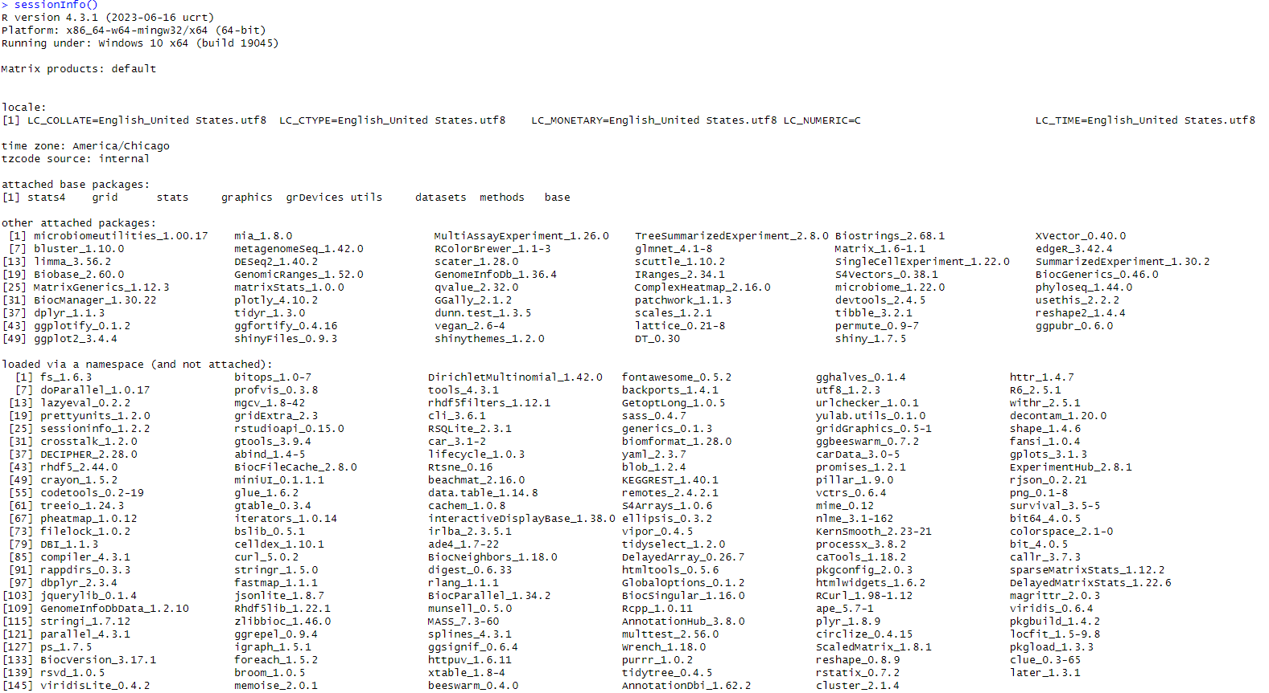

**Figure S44.** iMDGAVis application is developed and tested with the listed package version in Windows 10

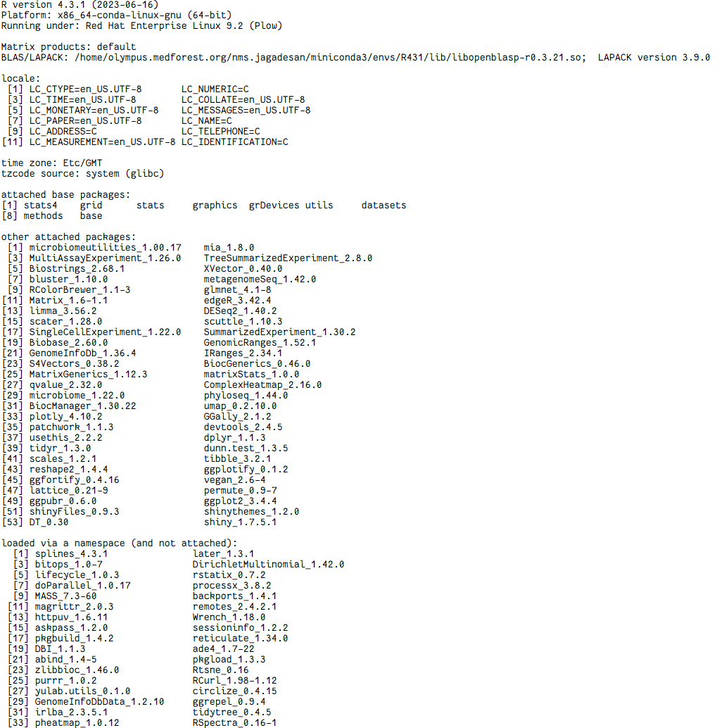

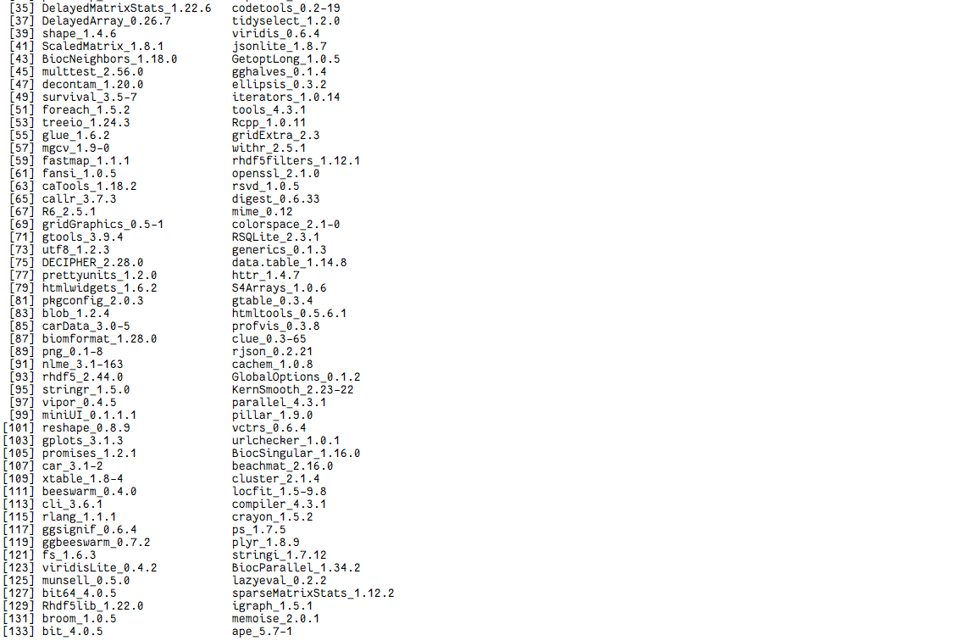

**Figure S45.** iMDGAVis application is developed and tested with the listed package version in RedHat

**References:**

* McMurdie and Holmes (2013) phyloseq: An R package for reproducible interactive analysis and graphics of microbiome census data PLoS ONE 8(4):e61217
* Oksanen, F.J., et al. (2017) Vegan: Community Ecology Package. R package Version 2.4-3. https://CRAN.R-project.org/package=vegan
* Chang W, Cheng J, Allaire J, Sievert C, Schloerke B, Xie Y, Allen J, McPherson J, Dipert A, Borges B (2022). shiny: Web Application Framework for R. R package version 1.7.4.9000, https://shiny.rstudio.com/.
* Wickham H (2016). ggplot2: Elegant Graphics for Data Analysis. Springer-Verlag New York. ISBN 978-3-319-24277-4, https://ggplot2.tidyverse.org.
* Wickham H (2007). "Reshaping Data with the reshape Package." Journal of Statistical Software, 21(12), 1–20. http://www.jstatsoft.org/v21/i12/.
* Tang Y, Horikoshi M, Li W (2016). "ggfortify: Unified Interface to Visualize Statistical Result of Popular R Packages." The R Journal, 8(2), 474–485. doi:10.32614/RJ-2016-060, https://doi.org/10.32614/RJ-2016-060.
* Müller K, Wickham H (2022). tibble: Simple Data Frames. https://tibble.tidyverse.org/, https://github.com/tidyverse/tibble.
* Wickham H, Seidel D (2022). scales: Scale Functions for Visualization. https://scales.r-lib.org, https://github.com/r-lib/scales.
* Gu Z (2022). "Complex Heatmap Visualization." iMeta. doi: 10.1002/imt2.43.
* Wickham H, Girlich M (2022). tidyr: Tidy Messy Data. https://tidyr.tidyverse.org, https://github.com/tidyverse/tidyr.
* Wickham H, François R, Henry L, Müller K (2022). dplyr: A Grammar of Data Manipulation. https://dplyr.tidyverse.org, https://github.com/tidyverse/dplyr.
* Pedersen T (2022). patchwork: The Composer of Plots. https://patchwork.data-imaginist.com, https://github.com/thomasp85/patchwork.
* McCarthy DJ, Campbell KR, Lun ATL, Willis QF (2017). "Scater: pre-processing, quality control, normalisation and visualisation of single-cell RNA-seq data in R." Bioinformatics, 33, 1179-1186. doi: 10.1093/bioinformatics/btw777.
* Love MI, Huber W, Anders S (2014). "Moderated estimation of fold change and dispersion for RNA-seq data with DESeq2." Genome Biology, 15, 550. doi: 10.1186/s13059-014-0550-8.
* Robinson MD, McCarthy DJ, Smyth GK (2010). "edgeR: a Bioconductor package for differential expression analysis of digital gene expression data." Bioinformatics, 26(1), 139-140. doi: 10.1093/bioinformatics/btp616.
* Paulson JN, Olson ND, Braccia DJ, Wagner J, Talukder H, Pop M, Bravo HC (2013). metagenomeSeq: Statistical analysis for sparse high-throughput sequencing. Bioconductor package, http://www.cbcb.umd.edu/software/metagenomeSeq.
* Ritchie ME, Phipson B, Wu D, Hu Y, Law CW, Shi W, Smyth GK (2015). "limma powers differential expression analyses for RNA-sequencing and microarray studies." Nucleic Acids Research, 43(7), e47. doi: 10.1093/nar/gkv007.
* Lun A (2022). bluster: Clustering Algorithms for Bioconductor. R package version 1.8.0.
* Ernst F, Shetty S, Borman T, Lahti L (2022). mia: Microbiome analysis. R package version 1.6.0, https://github.com/microbiome/mia.
* Schloerke B, Cook D, Larmarange J, Briatte F, Marbach M, Thoen E, Elberg A, Crowley J (2022). GGally: Extension to 'ggplot2'. https://ggobi.github.io/ggally/, https://github.com/ggobi/ggally.
* Kassambara A (2022). _ggpubr: 'ggplot2' Based Publication Ready Plots_. R package version 0.5.0, <https://CRAN.R-project.org/package=ggpubr>.
* Shetty S, Lahti L (2022). microbiomeutilities: microbiomeutilities: Utilities for Microbiome Analytics. R package version 1.00.17.
* Xie Y, Cheng J, Tan X (2022). _DT: A Wrapper of the JavaScript Library 'DataTables'_. R package version 0.26, <https://CRAN.R-project.org/package=DT>
* Dinno A (2017). _dunn.test: Dunn's Test of Multiple Comparisons Using Rank Sums_. R package version 1.3.5, <https://CRAN.R-project.org/package=dunn.test>.
* Pedersen T, Nijs V, Schaffner T, Nantz E (2022). _shinyFiles: A Server-Side File System Viewer for Shiny_. R package version 0.9.3, <https://CRAN.R-project.org/package=shinyFiles>.
* Chang W (2021). _shinythemes: Themes for Shiny_. R package version 1.2.0, <https://CRAN.R-project.org/package=shinythemes>.
* Wickham H, Hester J, Chang W, Bryan J (2022). _devtools: Tools to Make Developing R Packages Easier_. R package version 2.4.5, <https://CRAN.R-project.org/package=devtools>.
* Morgan M (2022). _BiocManager: Access the Bioconductor Project Package Repository_. R package version 1.30.19, <https://CRAN.R-project.org/package=BiocManager>.
* Storey JD, Bass AJ, Dabney A, Robinson D (2022). qvalue: Q-value estimation for false discovery rate control. R package version 2.30.0, <http://github.com/jdstorey/qvalue>.
* Yu G (2021). _ggplotify: Convert Plot to 'grob' or 'ggplot' Object_. R package version 0.1.0, <https://CRAN.R-project.org/package=ggplotify>.
* Leo Lahti et al. microbiome R package. URL: <http://microbiome.github.io>
* Sievert C (2020). Interactive Web-Based Data Visualization with R, plotly, and shiny. Chapman and Hall/CRC. ISBN 9781138331457, https://plotly-r.com.